
USER INTERFACE DESIGN
23CSE25248 LAB
MANUAL
SUBMITTED BY
NAME | K.SATYA MOHIT
ROLL NO | AV.SC.U4CSE25206
YEAR/SEM/SECTION | 1ST YEAR/ SEM-2/CSE-C
CREDITS | 03
SUBMITTED TO | DR. RAJ KUMAR BATCHU
DESIGNATION | ASST.PROFFESSOR (Sl. Grade)
DEPARTMENT | SCHOOL OF COMPUTING

INDEX
S.No | Title | Page.No | Remarks
1. | 1.Installation of vs code  2.understanding basics of html structure  3.understanding basics of html tags | 3-14
2. | Week2:A. desing a basic web page with headings ,paragraph,  table, by adding styles
3. | Week3:1.Create class timetable using html elements  2.Create a html web page that should display syllabus of all the subjects as an image format and also, the timetable
4. | Week4:A.Design a registration form using only HTML tags (no  CSS) with proper labels, table alignment, background  color, and borders.  B.Two forms displayed side by side using iframes .one is  login and another registration
5. | Week 5.:A.creating a card layout using <div> tag considerthree cards and a button using html and css  B.navigation using iframe (mini website) upon clicking each buttons the details about that button should be display on the same page  C.Design amrita login page by showing different  campus on home page.upon clicking on each campusthe details about each campus should be display on the same page use html and css to design a stylish webpage
6. | Week 6:A. : Design a responsive e-commerce application using the grid layout. This application should contain different categories of products such as electronics, clothing, home-appliances, books.  B: Design a responsive e-commerce application using the grid layout. This application should contain different categories of products such as electronics, clothing, home-appliances, books. Based on the category we select corresponding products should be displayed on the sidebar.
7. | Week 7:A.:create a GitHub account and create a repository in it and push all the week 6 code files in it.
8. | Week 8:A.:create a web page that displays a square that continuously rotates 360 using css animation  B.:create a ball that moves up and down continuously using css animation  C.:create a circle that moves horizontally and rotates at the same time

WEEK-1
1. AIM: To download vs code on laptop
PROCEDURE:
Step 1: Download VS Code
- Go to the VS Code website
- Click the Windows download button
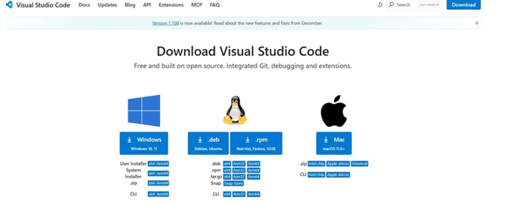

Step 2: Open the Installer & Accept License
- Double-click the downloaded setup file
- Select “I accept the agreement”
- Click Next
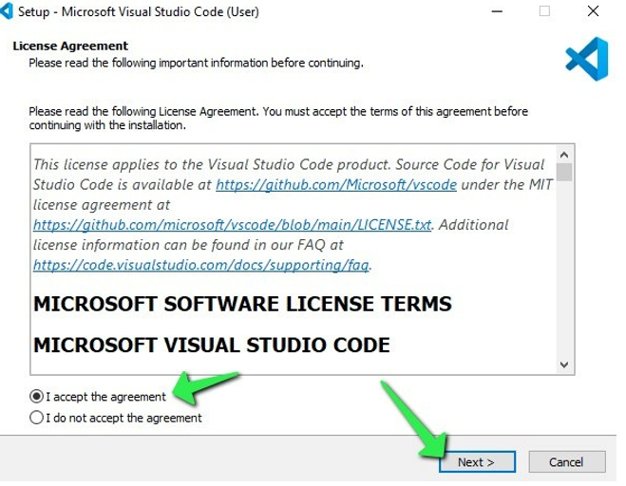
Step 3: Choose Installation Location
- Leave the default folder (recommended)
- Click Next
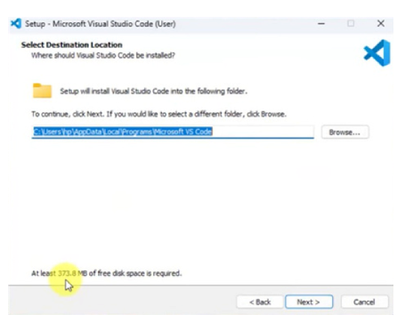
Step 4: Select Additional Tasks
Tick these options:
- Create Desktop Icon
- Add "Open with Code" to file menu
- Add "Open with Code" to folder menu
- Add to PATH
Then click Next
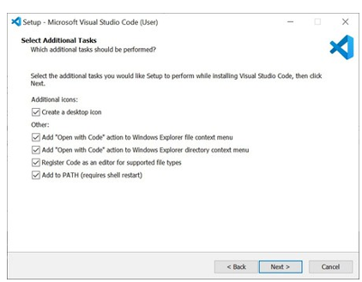
Step 5: Install VS Code
- Click Install
- Wait while files are extracted
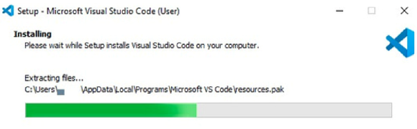

Step 6: Finish Setup
- Keep Launch Visual Studio Code checked
- Click Finish
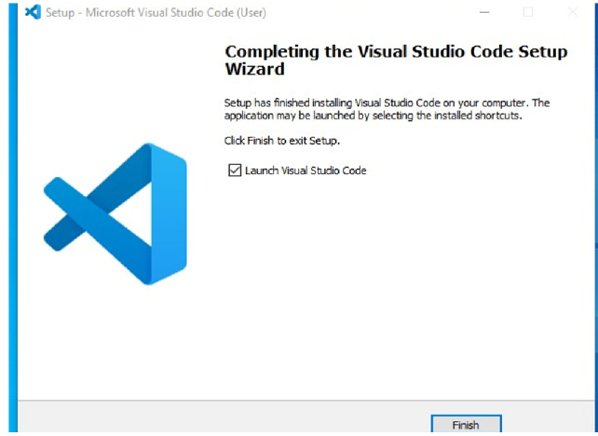
Step 7: VS Code Opens Successfully
You’ll see the Welcome Screen with options like:
• New File
• Open Folder
• Learn the Fundamentals
This means VS Code is installed correctly

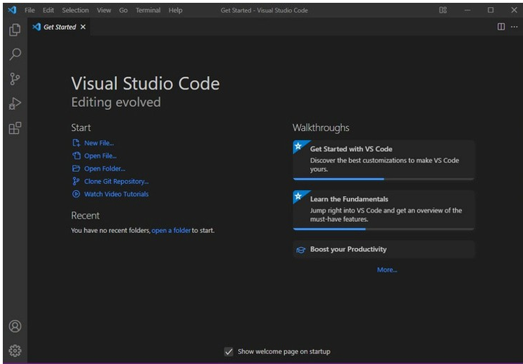

2.AIM: To write a basic HTML code
CODE:
<!DOCTYPE html>
<html>
<head>
<title>my first webpage</title>
</head>
<body>
<p>UID25206-K.Satya Mohit</p>
<h1>Welcome to My First Webpage</h1>
<p>This is a simple webpage created using HTML.</p>
</body>
</html>

Output:
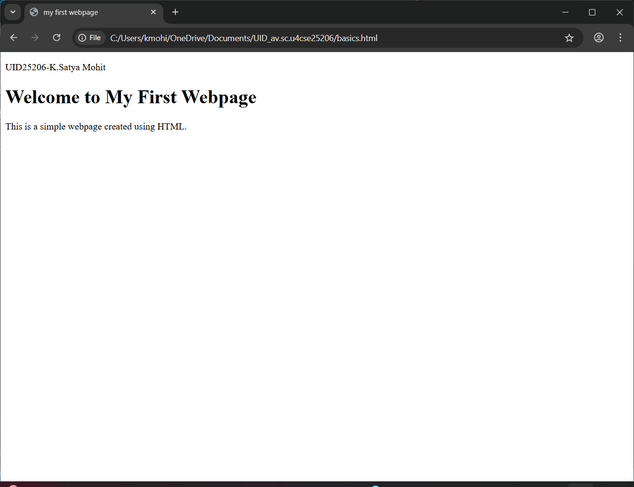
EXPLAINATION OF TAGS:-
- HTML stands for Hyper Text Markup Language.
- HTML is used to create and structure web pages.
- It tells the web browser what to display and how to display it.
- <DOCTYPE HTML>: The <DOCTYPE html>element tells the browser, this is an HTML5 document
- <html>: The <html> element is the root element of an HTML page.
- <head>: The <head> element contains meta information about the HTML page.
- <title>: The <title> element specifies a title for the HTML page.
- <body>: The <body>element contains all visible content like text, images, links, tables, etc.
- <h1>: The <h1> element defines a large heading.
- <p>: The <p> element defines a paragraph.

3.AIM: Understanding basic html tags.
Tags-<p>, <h1>, <img>, <color>, <br>
CODE:
<!DOCTYPE html>
<html>
<head>
<title>universities links</title>
</head>
<body>

<h1 style="color:red">AMRITA university</h1>
<p style="color:blue" >Amrita Vishwa Vidyapeetham, commonly known as Amrita University,<br> is a multi-campus,<br> multi-disciplinary private deemed university headquartered in Coimbatore, Tamil Nadu.<br> It is a highly-ranked institution,<br> accredited with an 'A++' grade by NAAC and consistently ranked among the top universities in India by NIRF.</p>
<a href="https://www.amrita.edu/">click here to visit amrita university</a>
<img src="https://upload.wikimedia.org/wikipedia/en/thumb/3/30/Amrita_Vishwa_Vidyapeetham_-_Logo_Icon.svg/250px-Amrita_Vishwa_Vidyapeetham_-_Logo_Icon.svg.png" alt="Amrita University Campus" width="500" height="300">
<h1 style="color:blue">SRM university</h1>
<p style="color:blue">SRM Institute of Science and Technology, formerly known as SRM University,<br> is a private deemed university located in Kattankulathur, Tamil Nadu, India.<br> Established in 1985, it has grown to become one of the largest private universities in India,<br> offering a wide range of undergraduate, postgraduate, and doctoral programs across various disciplines.</p>
<a href="https://www.srmist.edu.in/">click here to visit srm university</a>
<img src="https://images.seeklogo.com/logo-png/38/1/srm-institute-of-science-and-technology-logo-png_seeklogo-381994.png" alt="SRM University Campus" width="500" height="300">
<h1 style="color:brown">VIT university</h1>
<p style="color:blue">Vellore Institute of Technology (VIT) is a private deemed university located in Vellore, Tamil Nadu, India. Established in 1984, VIT has gained a reputation for its academic excellence, research contributions, and industry collaborations. The university offers a wide range of undergraduate, postgraduate, and doctoral programs across various disciplines, including engineering, technology, management, science, and humanities.</p>
<a href="https://vit.ac.in/">click here to visit vit university</a>
<img src="https://encrypted-tbn0.gstatic.com/images?q=tbn:ANd9GcS6-8IuoeRuatVDR8W0a_dpZLUDtlMJoCdQ1Q&s" alt="VIT University Campus" width="500" height="300">
</body>
</html>

OUTPUT:
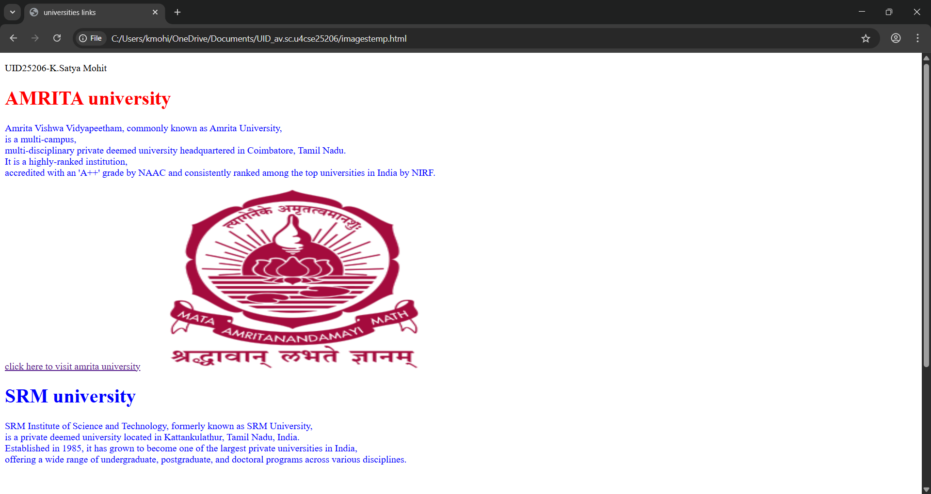

EXPLANATION:
- <p>: it is used if we want to display any information in para format.
- <h>: Used for titles and headings
- <a href="https://www.amrita.edu/"> amrita link</a>:
<a> is used it is usable one for link, Creates a clickable link
with name amrita link, href- specifies destination URL.
<img src="amrita.png" alt="Amrita" width="1200"
height="500">
- Displays an image on the webpage
- <img> has no closing tag
- src → image URL
- alt → text if image fails to load (important for accessibility)
- width → image width (pixels)
- height → image height (pixels)
- <br>: Moves text to the next line, No closing tag needed,
Used inside paragraphs for line breaks.
- Colour: it is a tag we used to color our text it used in <h>, <p>. main thing is the style tag should be used in that we add color as subtag.
Ex :<p style = "color: #F54927;">.

Week-2
2.A)Aim : desing a basic web page with headings ,paragraph,table, by adding styles

Program:
<!DOCTYPE html>
<html>
<head>
<title>Life Quote</title>
</head>
<body background="https://webfiles.amrita.edu/2020/05/IlZJZE8c-amrita-vishwa-vidyapeetham-coimbatore-campus-dron-image-01-2.jpg" style="background-size: cover;">
<p>K.Satya Mohit</p>
<p>av.sc.u4cse25206</p>
<table width="98%" border="4" style="text-align: center;border-color: blueviolet;font-size: larger;font-family: 'Times New Roman', Times, serif;color: brown;">
<tr>
<th style="border-color: transparent;">Life Quotes</th>
</tr>
</table>
<pre style="text-align: center;color: black;font-size:large;">
You are made of every moment you survived,
every lesson you learned,
and every dream you still chase.
Nothing was wasted.

</pre>
<table width="800" border="1" style="text-align: center;font-family: 'Times New Roman', Times, serif;background-image: url(Amaravati.jpg);background-repeat:no-repeat;background-size: cover; background-color: red;" align="center" cellspacing="10" cellpadding="10">
<caption style="background-color: darkred;font-size: x-large;font-family: Arial, Helvetica, sans-serif;">AMRITA VISHWA VIDYAPEETHAM</caption>
<tr style="background-color: aqua;">
<th>S.No</th>
<th>Campus</th>
<th>Location</th>
<th>Cantact No</th>
<th colspan="2">Contact Person</th>
</tr>
<tr>
<th style="background-color: aquamarine;">1</th>
<th style="background-color: aquamarine;">Amaravati</th>
<th style="background-color: azure;">Kuragallu</th>
<th rowspan="2">+91-9807654321</th>
<th>Rajkumar</th>
<th>Batchu</th>
</tr>
<tr>
<th style="background-color: aquamarine;">2</th>
<th style="background-color: aquamarine;">Amritapuri</th>
<th style="background-color: azure;">Amrita Nagar</th>
<th colspan="2">Adithya Ram</th>
</tr>
<tr>
<th style="background-color: aquamarine;">3</th>
<th style="background-color: aquamarine;">Coimbatoore</th>
<th style="background-color: azure;">Ettimadai</th>
<th >+91-9087654321</th>
<th>AAshish</th>
<th style="background-color: rgb(129, 26, 220);">B</th>
</tr>
</table>
</body>
</html>

Output:-
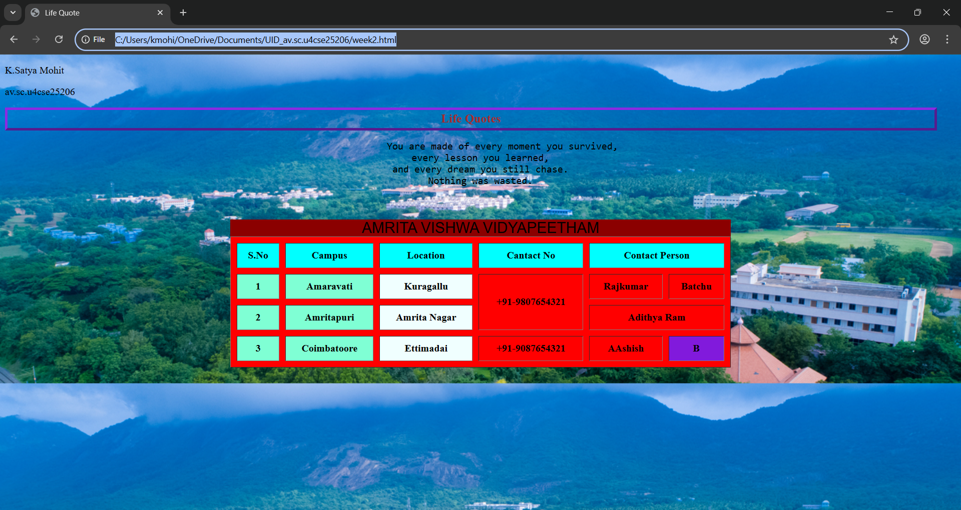

Explanation :
. <DOCTYPE html> : the <!DOCTYPE html> element tells the web browser that this an HTML document
or this is the latest version of HTML
. <html> : the <html> element is the root element of an HTML web page
. <head> : the <head> element will contain meta data about the HTML web page
. <title> : the <title> element specifies a title for the HTML Page
. <body> : the <body> element contains all visible content all visible content like text , image , links ,
tables , etc
. <table>: the element <table> is used to create a table
. <tr>: the element <tr> creates a new row in the table
. <th>: the element <th> create a new heading inside the table
. <td>: the element <td> fill the columns in the row
. <button>: the element <button> is used for button .

Week-3
Q1.Create a class timetable by using HTML by using tags like <table>,<td>,<th>,<tr>,and using style attribute in it?

Program:-
<!DOCTYPE html>
<html>
<head>
<title>Time Table</title>
</head>
<body>
<table border="1" style="width: 80%; margin: auto; text-align: center; cellpadding: 10px;cellborder: 2px solid black;cellspacing: 01; border-collapse: collapse;">
<p>K.Satya Mohit</p>
<p>av.sc.u4cse25206</p>

<tr>
<th colspan="14" style="background-color: yellow;">Master Time Table CSE II semister c section</th>
</tr>

<tr>
<th colspan="4">Dept:CSE</th>
<th rowspan="3" colspan="10">classroom venue:512</th>
</tr>
<tr>
<th colspan="4">Class: B.tech,CSE-C </th>
</tr>
<tr>
<th colspan="4">Semester: II</th>
</tr>
<tr>
<th colspan="4">class advisors:1.Mr.Budati Jaya Lakshminarayana</th>
<th colspan="10">2.Dr. Arun Kumar S</th>
</tr>

<tr>
<th colspan="14" style="background-color: yellow; font-size: 24px;">Time Table</th>
</tr>

<tr>
<th rowspan="2">time/day</th>
<th>slot-1</th>
<th>slot-2</th>
<th style="background-color: yellow; writing-mode: vertical-rl; " rowspan="7" width="40px">Break</th>
<th>slot-3</th>
<th>slot-4</th>
<th>slot-5</th>
<th rowspan="7" style="background-color: yellow; writing-mode: vertical-rl; " width="50px">Lunch-Break</th>
<th>slot-6</th>
<th rowspan="7" style="background-color: yellow; writing-mode: vertical-rl;" width="40px">Small Break</th>
<th>slot-7</th>
<th>slot-8</th>
</tr>
<tr>
<th>08.50-09.40am</th>
<th>9.40-10.30am</th>
<th>10.40-11.30am</th>
<th>11.30-12.20pm</th>
<th>12.20-01.10pm</th>
<th>02.30-03.20pm</th>
<th>03.20-04.10pm</th>
<th>04.10-05.00pm</th>
</tr>
<tr>
<td>MONDAY</td>
<td>object oriented programming</td>
<td>user interface design</td>
<td>discrete maths lab</td>
<td>library</td>
<td>GGI(p)</td>
<td>GGI</td>
<td colspan="2">sports</td>
</tr>
<tr>
<td>TUESDAY</td>
<td colspan="2">oops lab</td>
<td>linear algebra</td>
<td>discrete maths</td>
<td style="color: red;">counselling</td>
<td>manufacturing lab</td>
<td colspan="2">manufacturing lab</td>
</tr>
<tr>
<td>WEDNESDAY</td>
<td>modern physics</td>
<td>user interface design</td>
<td colspan="2">linear algebra</td>
<td style="color: red;">counselling</td>
<td>library</td>
<td colspan="2">library</td>
</tr>
<tr>
<td>THURSDAY</td>
<td>object oriented programming</td>
<td>discrete maths</td>
<td colspan="2">object oriented programming (p)</td>
<td>linear algebra</td>
<td>library</td>
<td colspan="2">library</td>
</tr>
<tr>
<td>FRIDAY</td>
<td>object oriented programming</td>
<td>discrete maths</td>
<td>Modern physics</td>
<td>user interface design</td>
<td>linear algebra</td>
<td>library</td>
<td colspan="2">library</td>
</table>

<table border="1" width="100%" cellpadding="6" cellspacing="0">
<tr>
<th>Course code</th>
<th>Course Name</th>
<th>Faculty name</th>
<th>L-T-P</th>
<th>Credits</th>
</tr>
<tr>
<td>23MAT116</td>
<td>Discrete Mathematics</td>
<td>Dr.bixapathi</td>
<td>3-0-0</td>
<td>3</td>
</tr>
<tr>
<td>23PHY115</td>
<td>Modern Physics</td>
<td>Dr.sowmya</td>
<td>3-0-0</td>
<td>3</td>
</tr>
<tr>
<td>23CSE111</td>
<td>OOP</td>
<td>Dr.satya rajendra singh</td>
<td>3-0-0</td>
<td>3</td>
</tr>
<tr>
<td>22ADM111</td>
<td>GGI</td>
<td>DR.siva panuganti</td>
<td>2-0-0</td>
<td>2</td>
</tr>
<tr>
<td>23CSE113</td>
<td>UI Design</td>
<td>Dr.rajshekar batchu</td>
<td>3-0-0</td>
<td>3</td>
</tr>
<tr>
<td>23MEE115</td>
<td>Manufacturing Practice</td>
<td>Dr.sathies</td>
<td>0-0-3</td>
<td>1</td>
</tr>
<tr>
<td>23MAT116</td>
<td>Discrete Mathematics Lab</td>
<td>Dr.Thota srinivas rao</td>
<td>0-0-2</td>
<td>1</td>
</tr>
</table>

</body>
</html>

Output:-

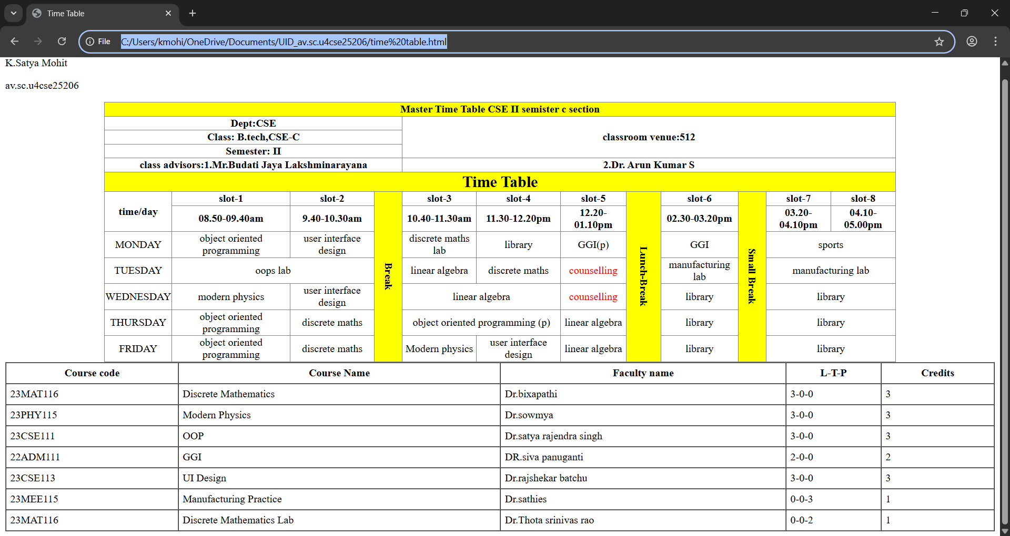
Explanation:
1. <!DOCTYPE html> tells the browser this is a webpage.
2.<html> starts and ends the webpage.
3.<head> contains page details.
4.<title> shows webpage name on browser tab.
5.<body> shows all content on the screen.
6.Font style is changed using font-family.
7.Margin gives space around the page.
8.<h2> shows the main timetable heading.
9.<h3> shows class and semester details.
10.<table> is used to create timetable structure.
11.border="1" adds lines around the table.
12.<tr> is used to create rows.
13.<td> is used to enter data in rows.
14.<th> is used to create headings in table.
15.<colspan> is used when one subject covers two periods.
16.<rowspan> is used when break or lunch covers many rows.
17.<br> is used to move text to the next line.
18.Yellow background is used to highlight break and lunch.
Different rows represent different days of the week.
Another table is used to show course code, faculty name, and credits.

Q2. to create the timetable with the respective syllabus at the end of the page:-

Program:-
<!DOCTYPE html>
<html>
<head>
<title>Time Table</title>
</head>
<body>
<table border="1" style="width: 80%; margin: auto; text-align: center; cellpadding: 10px;cellborder: 2px solid black;cellspacing: 01; border-collapse: collapse;">
<p>K.Satya Mohit</p>
<p>av.sc.u4cse25206</p>

<tr>
<th colspan="14" style="background-color: yellow;">Master Time Table CSE II semister c section</th>
</tr>

<tr>
<th colspan="4">Dept:CSE</th>
<th rowspan="3" colspan="10">classroom venue:512</th>
</tr>
<tr>
<th colspan="4">Class: B.tech,CSE-C </th>
</tr>
<tr>
<th colspan="4">Semester: II</th>
</tr>
<tr>
<th colspan="4">class advisors:1.Mr.Budati Jaya Lakshminarayana</th>
<th colspan="10">2.Dr. Arun Kumar S</th>
</tr>

<tr>
<th colspan="14" style="background-color: yellow; font-size: 24px;">Time Table</th>
</tr>

<tr>
<th rowspan="2">time/day</th>
<th>slot-1</th>
<th>slot-2</th>
<th style="background-color: yellow; writing-mode: vertical-rl; " rowspan="7" width="40px">Break</th>
<th>slot-3</th>
<th>slot-4</th>
<th>slot-5</th>
<th rowspan="7" style="background-color: yellow; writing-mode: vertical-rl; " width="50px">Lunch-Break</th>
<th>slot-6</th>
<th rowspan="7" style="background-color: yellow; writing-mode: vertical-rl;" width="40px">Small Break</th>
<th>slot-7</th>
<th>slot-8</th>
</tr>
<tr>
<th>08.50-09.40am</th>
<th>9.40-10.30am</th>
<th>10.40-11.30am</th>
<th>11.30-12.20pm</th>
<th>12.20-01.10pm</th>
<th>02.30-03.20pm</th>
<th>03.20-04.10pm</th>
<th>04.10-05.00pm</th>
</tr>
<tr>
<td>MONDAY</td>
<td>object oriented programming</td>
<td>user interface design</td>
<td>discrete maths lab</td>
<td>library</td>
<td>GGI(p)</td>
<td>GGI</td>
<td colspan="2">sports</td>
</tr>
<tr>
<td>TUESDAY</td>
<td colspan="2">oops lab</td>
<td>linear algebra</td>
<td>discrete maths</td>
<td style="color: red;">counselling</td>
<td>manufacturing lab</td>
<td colspan="2">manufacturing lab</td>
</tr>
<tr>
<td>WEDNESDAY</td>
<td>modern physics</td>
<td>user interface design</td>
<td colspan="2">linear algebra</td>
<td style="color: red;">counselling</td>
<td>library</td>
<td colspan="2">library</td>
</tr>
<tr>
<td>THURSDAY</td>
<td>object oriented programming</td>
<td>discrete maths</td>
<td colspan="2">object oriented programming (p)</td>
<td>linear algebra</td>
<td>library</td>
<td colspan="2">library</td>
</tr>
<tr>
<td>FRIDAY</td>
<td>object oriented programming</td>
<td>discrete maths</td>
<td>Modern physics</td>
<td>user interface design</td>
<td>linear algebra</td>
<td>library</td>
<td colspan="2">library</td>
</table>

<table border="1" width="100%" cellpadding="6" cellspacing="0">
<tr>
<th>Course code</th>
<th>Course Name</th>
<th>Faculty name</th>
<th>L-T-P</th>
<th>Credits</th>
</tr>
<tr>
<td>23MAT116</td>
<td>Discrete Mathematics</td>
<td>Dr.bixapathi</td>
<td>3-0-0</td>
<td>3</td>
</tr>
<tr>
<td>23PHY115</td>
<td>Modern Physics</td>
<td>Dr.sowmya</td>
<td>3-0-0</td>
<td>3</td>
</tr>
<tr>
<td>23CSE111</td>
<td>OOP</td>
<td>Dr.satya rajendra singh</td>
<td>3-0-0</td>
<td>3</td>
</tr>
<tr>
<td>22ADM111</td>
<td>GGI</td>
<td>DR.siva panuganti</td>
<td>2-0-0</td>
<td>2</td>
</tr>
<tr>
<td>23CSE113</td>
<td>UI Design</td>
<td>Dr.rajshekar batchu</td>
<td>3-0-0</td>
<td>3</td>
</tr>
<tr>
<td>23MEE115</td>
<td>Manufacturing Practice</td>
<td>Dr.sathies</td>
<td>0-0-3</td>
<td>1</td>
</tr>
<tr>
<td>23MAT116</td>
<td>Discrete Mathematics Lab</td>
<td>Dr.Thota srinivas rao</td>
<td>0-0-2</td>
<td>1</td>
</tr>
</table>
<h1 style="background-color: yellow;">Discrete Mathematics</h1>
<p>Syllabus<br><br>

Unit 1
Logic, Mathematical Reasoning and Counting: Logic, Prepositional Equivalence, Predicate and Quantifiers, Theorem
Proving. Recursive Definitions, Recursive Algorithms, Basics of Counting, Pigeonhole Principle, Permutation and
Combinations.<br><br>

Unit 2
Relations and Their Properties: Representing Relations, Closure of Relations, Partial Ordering, Equivalence Relations and
partitions.
Advanced Counting Techniques and Relations: Recurrence Relations, Solving Recurrence Relations, Generating
Functions, Solutions of Homogeneous Recurrence Relations, Divide and Conquer Relations, Inclusion-Exclusion.<br><br>

Unit 3
Graph Theory: Graphs and Sub graphs, isomorphism, matrices associated with graphs, degrees, walks, connected graphs,
shortest path algorithm. Euler and Hamilton Graphs: Euler graphs, Euler's theorem. Fleury's algorithm for Eulerian trails.
Hamilton cycles, Chinese-postman problem, approximate solutions of traveling salesman problem. Closest neighbour
algorithm.<br></p>
<h1 style="background-color: yellow;">Linear Algebra</h1>
<p>Syllabus<br><br>
Unit 1
Vector Spaces: Vector spaces - Sub spaces - Linear independence - Basis-Dimension; Inner Product Spaces: Inner products
- Orthogonality - Orthogonal basis - Gram Schmidt Process - Change of basis - Orthogonal complements - Projection on
subspace - Least Square Principle. QR- Decomposition.<br><br>

Unit 2
Linear Transformations: Linear transformation - Relation between matrices and linear transformations - Kernel and range
of a linear transformation - Change of basis - Nilpotent transformations. Symmetric and Skew Symmetric Matrices, Adjoint
and Hermitian Adjoint of a Matrix, Hermitian, Unitary and Normal Transformations, Self-Adjoint and Normal
Transformations.<br><br>

Unit 3
Eigen values and Eigen vectors: Eigen Values and Eigen Vectors, Diagonalization, Orthogonal Diagonalization, Quadratic
Forms, Diagonalizing Quadratic Forms, Conic Sections.
applications - Jordan form and rational canonical form. Case Studies: Applications on least square and image
transformations.<br><br> </p>
<h1 style="background-color: yellow;">Object Oriented Programming</h1>
<p>Syllabus<br><br>

Unit1
Structured to Object Oriented Approach by Examples - Object Oriented languages - Properties of Object Oriented system -
UML and Object Oriented Software Development - Use case diagrams and documents as a functional model - Identifying
Objects and classes - Representation of Objects and its state by Object Diagram - Simple Class using class diagram -
Encapsulation - Data Hiding - Reading and Writing Objects - Class Level and Instance Level Attributes and Methods- JIVE
environment for debugging.<br><br>

Unit2
Aggregation and Composition using Class Diagram -Generalization using Class Diagram - Inheritance - 'Constructor and
Over Riding - Visibility - Attribute - Parameter - Package - Local and Global - Polymorphism - Overloading - Abstract
Classes and Interfaces.<br><br>

Unit3
Exception Handling - Inner Classes - Wrapper classes - String - and String Builder classes - Number - Math - Random -
Array methods - File Streams - Serialization - Generics - Collection framework - Comparator and Comparable - Vector and
Arraylist - Iterator and Iterable.<br><br></p>
<h1 style="background-color: yellow;">Modern Physics</h1>
<p>Syllabus<br><br>

Unit 1
Origin of quantum theory of radiation: Black body radiation, photo-electric effect, Compton Effect - pair production and
annihilation, De-Broglie hypothesis, description of waves and wave packets,group velocities. Evidence for wave nature of
particles: Davisson-Germer experiment, Heisenberguncertainty principle.<br><br>

Unit 2
Atomic structure: Historical Development of atomic structures: Thomson's Model, Rutherford's Model: Scattering
formula and its predictions, Atomic spectra - Bohr's Model, Sommerfield's Model, The correspondence principle, nuclear
motion, and atomic excitation, Application: Lasers.<br><br>

Unit 3
Quantum mechanics: Wave function, Probability density, expectation values - Schrodinger equation - time dependent
and independent, Linearity and superposition, expectation values, operators, Eigen functions and Eigen values<br><br>

Unit 4
Application of 1D Schrodinger Wave equation: Free particle, Particle in a box, Finite potential well,Tunnel effect,
Harmonic oscillator.<br><br>

Unit 5
Intro to Quantum computing- Q bits- II Quantum correlations: Bell inequalities and entanglement,Schmidt
decomposition, super dense coding, teleportation. Module<br><br></p>

<h1 style="background-color: yellow;">UI Design</h1>
<p>Syllabus<br><br>
Unit 1
Introduction to Internet and Web design - Working of Web - Roles of Front-end, Back-end and Full stack development -
Web Server - Internet protocols - Web Hosting -HTML -HTML Tags-Create a simple Web Page - Marking up Text -
Adding Links-Adding Images-SVG-Table Markup- Embedded Media - Web Based Forms - HTML Forms- CSS for
Presentation - Basic Style Sheet - A CSS Style Primer - Using Style Classes - Using Style IDs - Formatting Text - Advanced
Typography with CSS3 - Working with Margins, Padding, Alignment, and Floating. Responsive web design, Introduction
to version control systems.<br><br>

Unit 2
CSS Box Model and Positioning - Creating Layouts Using Modern CSS - Backgrounds and Borders - CSS Transformations
and Transitions - Animating with CSS and the Canvas - Dynamic Web Pages - Web Scripting - JavaScript programming
for Web Applications-Including JavaScript in HTML - HTML5 Form Controls and Validation - Document Object Model
- DOM manipulation and events - Event Handlers<br><br>

Unit 3
Overview of UI Frameworks - User Interface Design Concepts in Web Development - Accessibility - Introduction to
Electron - Overview of Electron - Setting up an Electron project - Creating a basic desktop application with Electron - Object
communication - Introduction to other popular frameworks and libraries (c.g., JavaFX, WPF, GTK).<br><br></p>

<h1 style="background-color: yellow;">Manufacturing Practice</h1>
<p>Syllabus<br><br>
1. Additive Manufacturing Laboratory -12 hours
Introduction to digital manufacturing. Introduction to Additive Manufacturing - types - additive manufacturing
applications - Materials for 3D printing, CAD Modelling for Additive manufacturing, Slicing and STL file gencration- G
code gencration - 3D printing of simple geometries.<br><br>
2. Mechanical Engincering Laboratory -12 hours
Study of tools and equipment used for basic manufacturing processes.
Manual arc welding practice for making Butt and Lap joints - Soldering Practice
Introduction to Machine Tools and Machining Processes<br><br>
3. Automation lab -12 hours
Design, simulate and test pneumatic and electro-pneumatic circuits. Introduction to PLC-PLC programming for
automation applications<br><br>
4. Automobile Engineering lab -9 hours
Overview of automobiles - components -functioning of various sub-systems; Power train, steering system, suspension
system and braking system. Introduction to electric vehicles, hybrid vehicles, alternate fuels. Introduction to E Mobility.<br><br></p>
<h1 style="background-color: yellow;">GGI</h1>
<p>Syllabus<br><br>
Face the Brutes, Role of Women in India, Acharya Chanakya, God and Iswara, Bhagavad Gita: From Soldier to Samsarin
to Sadhaka, Lessons of Yoga from Bhagavad Gita, Indian Soft powers, Preserving Nature through Faith, Ancient Indian
Cultures (Class Activity), Practical Vedanta, To the World from India, Indian Approach to Science.<br><br></p>

</body>
</html>

Output:-
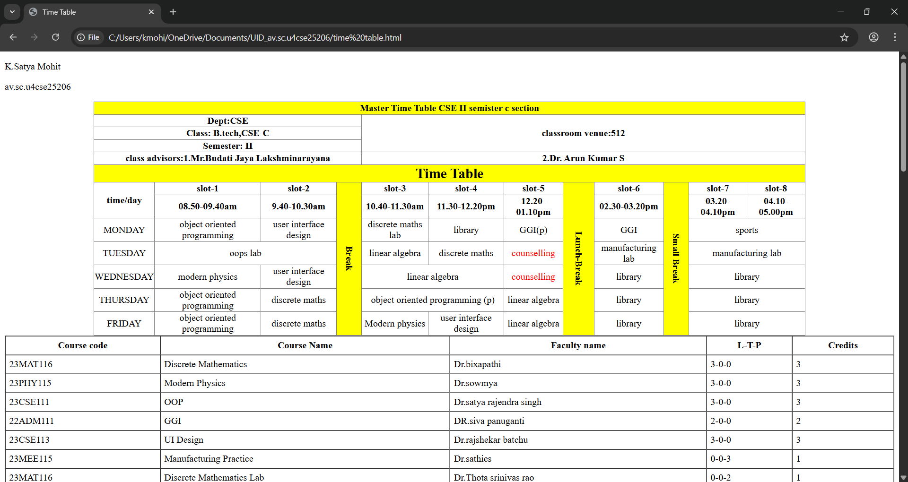

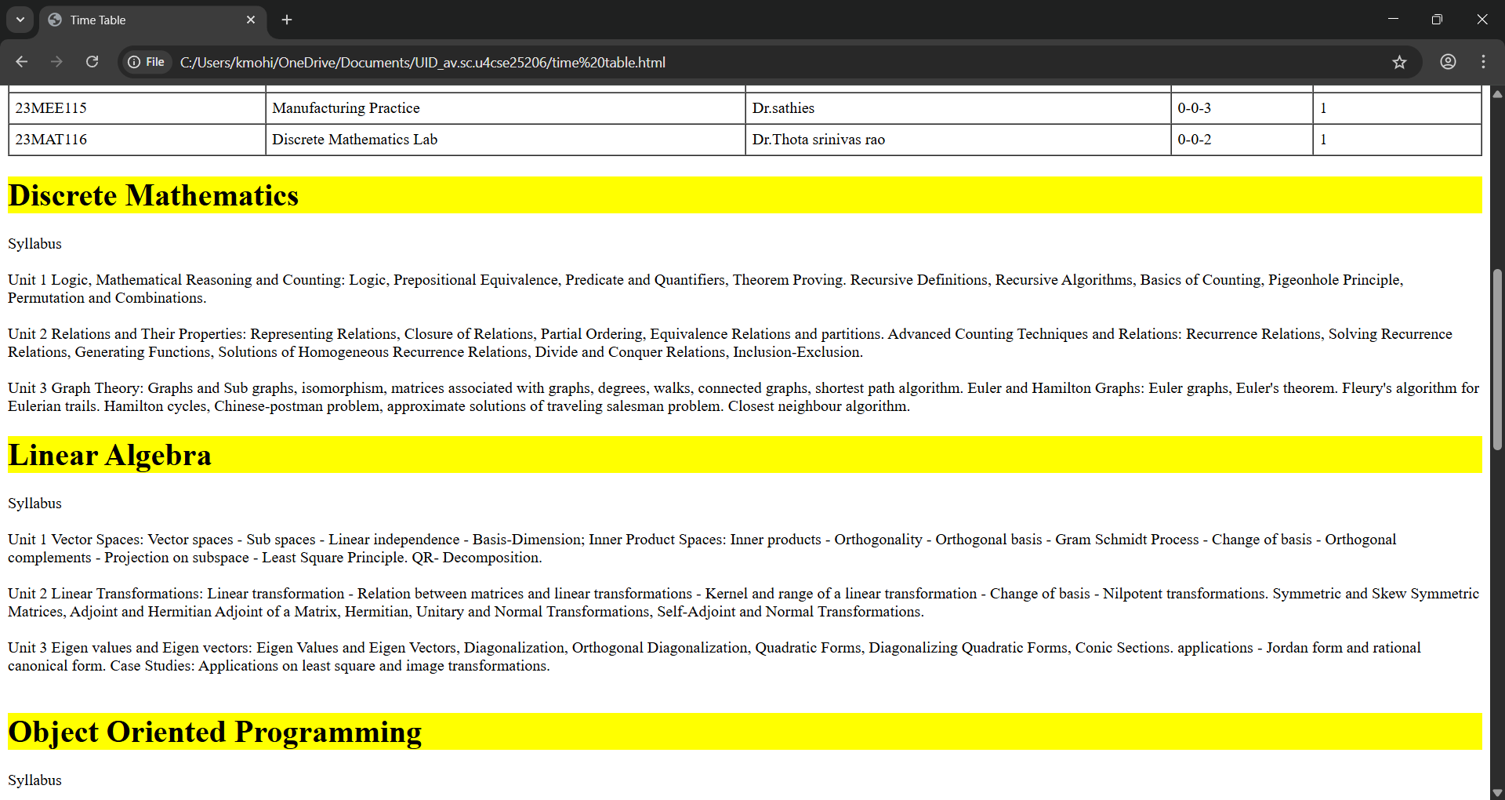

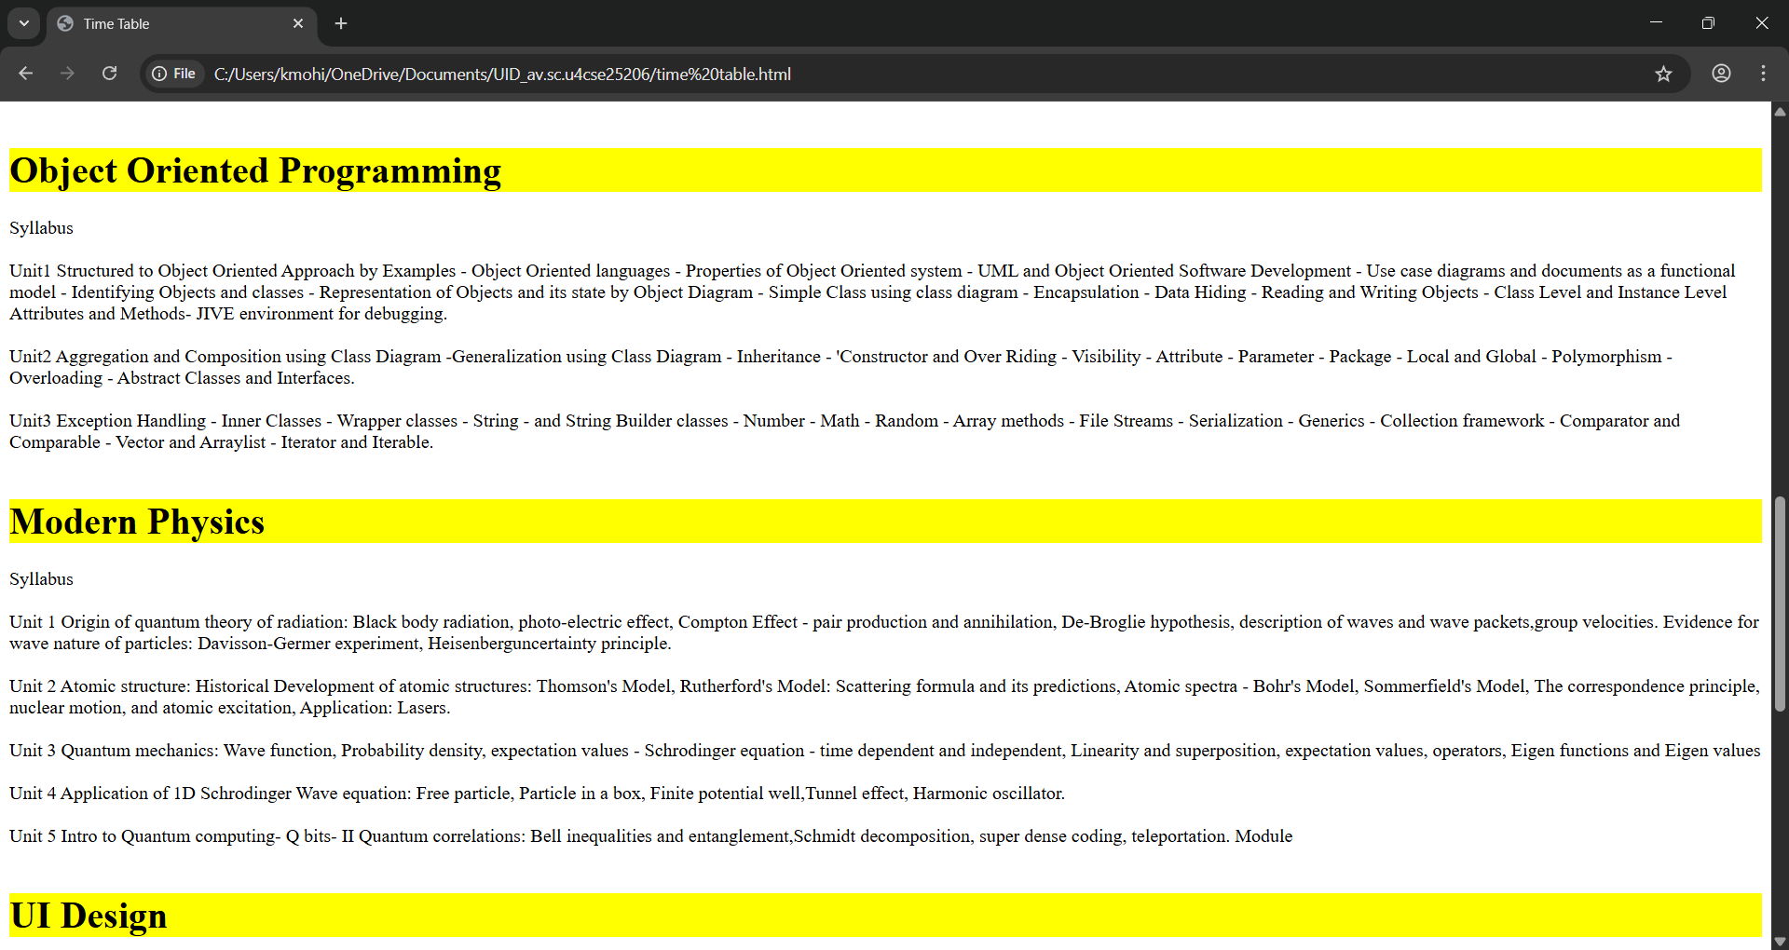

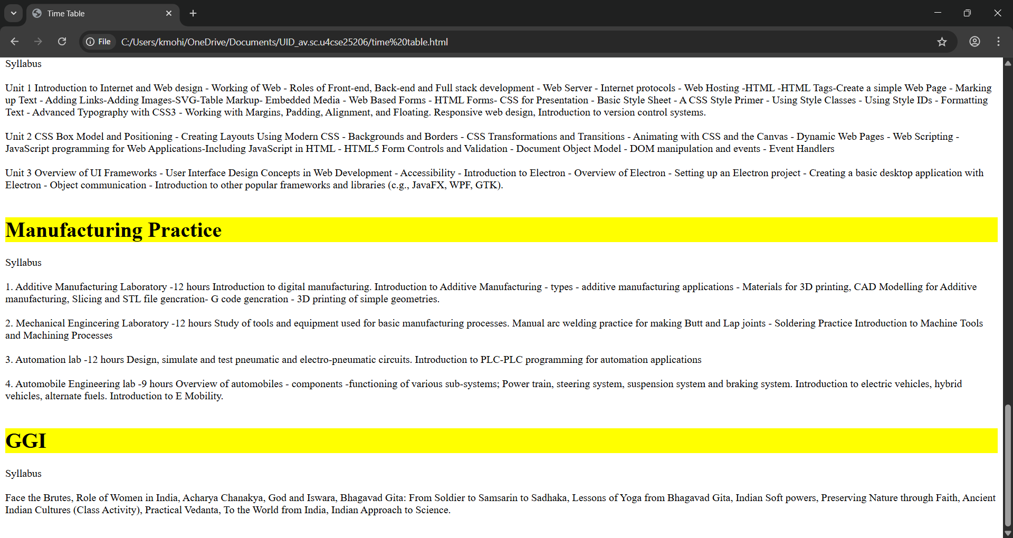

Week-4:-
4.A)Aim: Design a registration form using only HTML tags (no CSS) with proper labels, table
alignment, background color, and borders.

Program:-
<!DOCTYPE html>
<html>
<body>
<p>K.Satya Mohit</p>
<p>av.sc.u4cse25206</p>
<h1 align="center">HTML Forms</h1>
<table border="1" cellpadding="10" cellspacing="0" align="center">
<tr>
<th>Full Name</th>
<td><input type="text" name="fname"></td>
</tr>
<tr>
<th>Email</th>
<td><input type="email" name="email"></td>
</tr>
<tr>
<th>Phone Number</th>
<td><input type="tel" name="phone"></td>
</tr>
<tr>
<th>Gender</th>
<td>
<input type="radio" name="gender" value="male"> Male
<input type="radio" name="gender" value="female"> Female
<input type="radio" name="gender" value="other"> Other
</td>
</tr>
<tr>
<th>Course Applying for?</th>
<td>
<select name="course">
<option value="bt">BTech</option>
<option value="bba">BBA</option>
<option value="mbbs">MBBS</option>
</select>
</td>
</tr>
<tr>
<th>Hobbies</th>
<td>
<input type="checkbox" name="hobby" value="sports"> Sports
<input type="checkbox" name="hobby" value="music"> Music
<input type="checkbox" name="hobby" value="reading"> Reading
</td>
</tr>
<tr>
<th>Date of Birth</th>
<td><input type="date" name="dob"></td>
</tr>
<tr>
<th>Upload Certificate</th>
<td><input type="file" name="certi"></td>
</tr>
<tr>
<th>Address</th>
<td><textarea name="address" rows="4" cols="50"></textarea></td>
</tr>
<tr>
<td colspan="2" align="center"><input type="submit" value="Submit"><input type="reset" value="Reset"></td>
</tr>
</table>
</body>

Output:-
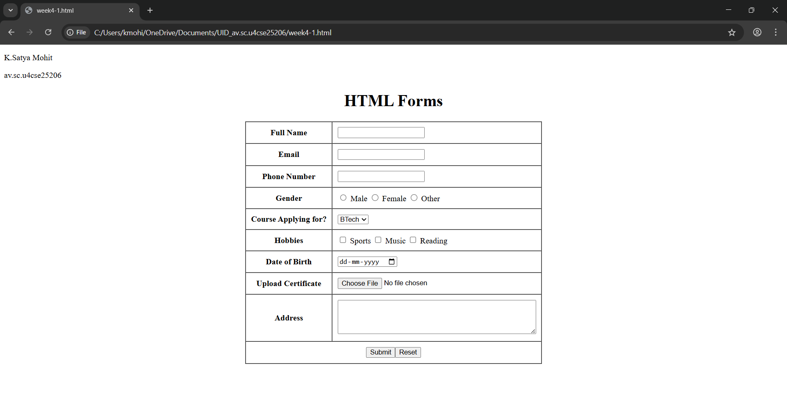
Explanation :
<DOCTYPE html> : the <!DOCTYPE html> element tells the web browser that this an HTML document
or this is the latest version of HTML
<html> : the <html> element is the root element of an HTML web page
<head> : the <head> element will contain meta data about the HTML web page
<title> : the <title> element specifies a title for the HTML Page
<body> : the <body> element contains all visible content all visible content like text , image , links ,
tables , etc
<h> : we used <h> element for heading
<p> : we used <p> element for the paragraph
<table>: the element <table> is used to create a table
<tr>: the element <tr> creates a new row in the table
<th>: the element <th> create a new heading inside the table
<td>: the element <td> fill the columns in the row
<label>:we used <label> element for linking the input to specific id name and we use for attribute for it
<input>:we use <input> element for the input elements in the forms
<select>:we use <select> element for creation of drop box
<option>:we use <option> element for creating the options in the drop box

4.B)Aim: Two forms displayed side by side using iframes .one is login and another registration
Program :

Main Program:-
<!DOCTYPE html>
<html>
<head>
<title>Two Forms Using Iframes</title>
<style>
body {
font-family: Arial, sans-serif;
background-color: #f2f2f2;
text-align: center;
}

h2 {
margin-top: 20px;
}

.container {
display: flex;
justify-content: center;
gap: 40px;
margin-top: 30px;
}

iframe {
width: 350px;
height: 300px;
border: 2px solid #555;
background-color: #fff;
}
</style>
</head>
<body>
<p>K.Satya Mohit</p>
<p>av.sc.u4cse25206</p>

<h2>Two Forms Displayed Using Iframes</h2>

<div class="container">
<iframe src="login.html" name="loginFrame"></iframe>
<iframe src="register.html" name="registerFrame"></iframe>
</div>

</body>
</html>

Login Code:-
<!DOCTYPE html>
<html>
<head>
<title>Login Form</title>
</head>
<body style="background-color: antiquewhite; font-family: Arial; text-align: center;">

<div class="box">
<h3>User Login</h3>

<form >
<table style="text-align: center;" align="center" cellpadding="10" cellspacing="0" border="1">
<tr>
<td>Username:</td>
<td><input type="text" name="username"></td>
</tr>
<tr></tr>
<td>Password:</td>
<td><input type="password" name="password"></td>
</tr>
<tr>
<td colspan="2" align="center"><button type="submit">Login</button></td>
</tr>
</table>
</form>
</div>

</body>
</html>

Registration Code:-
<!DOCTYPE html>
<html>
<head>
<title>Registration Form</title>
</head>
<body style="background-color: antiquewhite; font-family: Arial; text-align: center;">

<div class="box">
<h3>User Registration</h3>

<form>
<table style="text-align: center;" align="center" cellpadding="10" cellspacing="0" border="1">
<tr>
<th>Field</th>
<th>Input</th>
</tr>
<tr>
<td>Full Name:</td>
<td><input type="text" name="fullname"></td>
</tr>
<tr>
<td>Email:</td>
<td><input type="email" name="email"></td>
</tr>
<tr>
<td>Phone Number:</td>
<td><input type="tel" name="phone"></td>
</tr>
<tr>
<td>Password:</td>
<td><input type="password" name="password"></td>
</tr>
<tr>
<td colspan="2" align="center"><button type="submit">Register</button> <button type="reset">Reset</button></td>
</tr>
</table>
</form>
</div>

</body>
</html>

Output:-
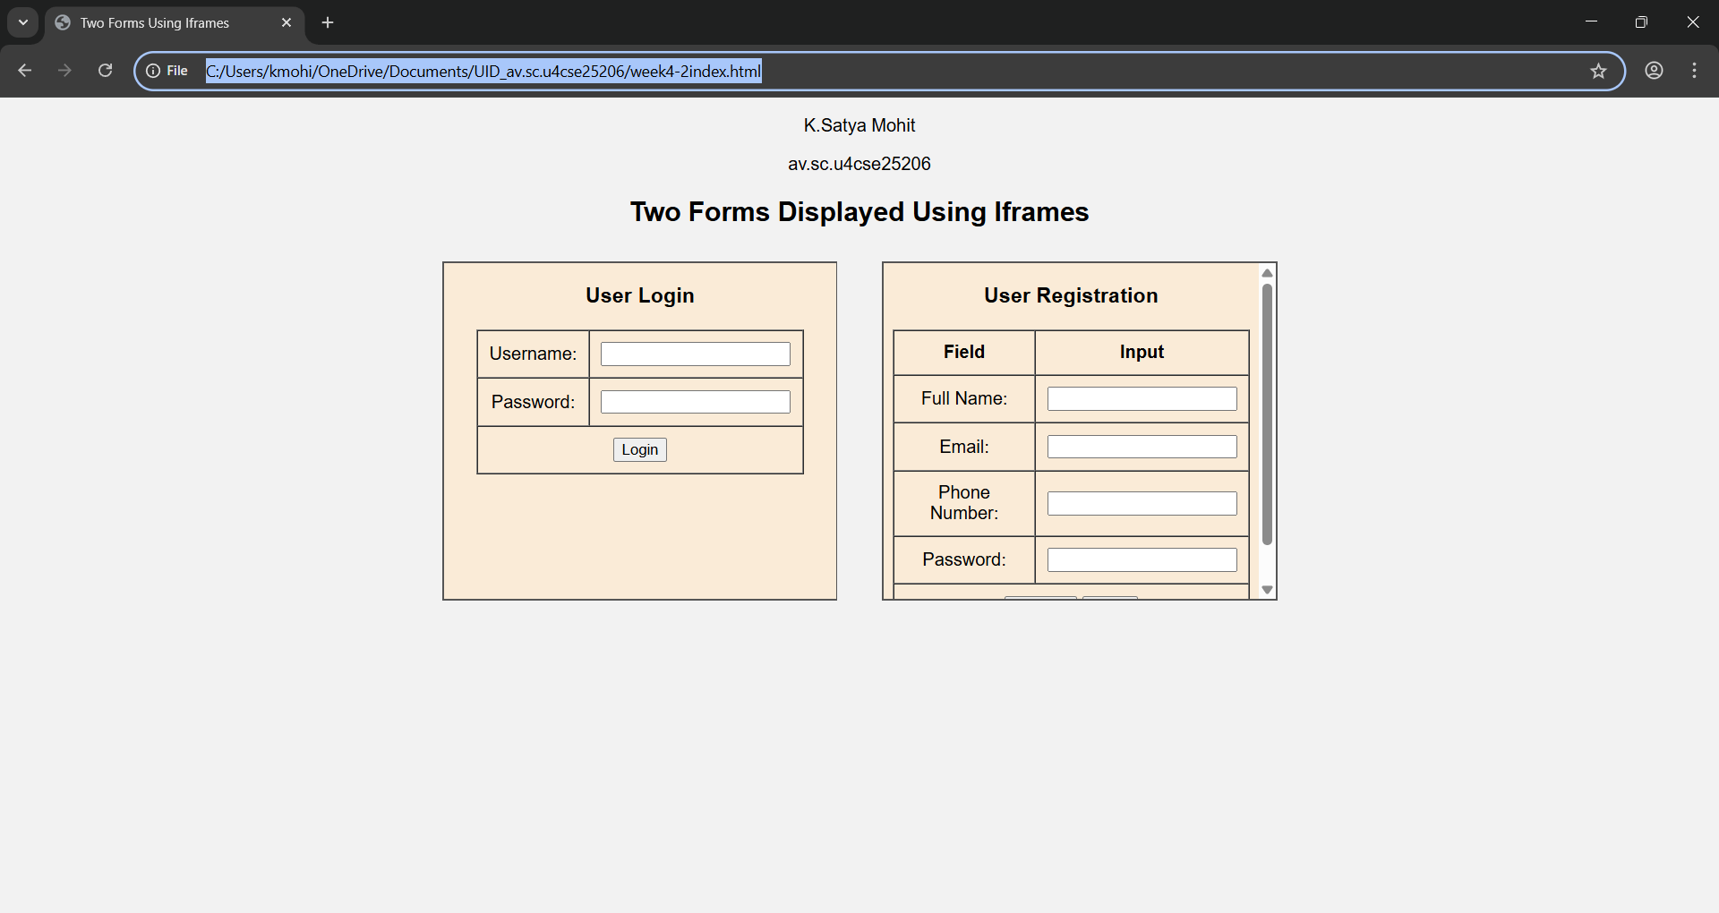

Explanation :
<DOCTYPE html> : the <!DOCTYPE html> element tells the web browser that this an HTML document
or this is the latest version of HTML
<html> : the <html> element is the root element of an HTML web page
<head> : the <head> element will contain meta data about the HTML web page
<title> : the <title> element specifies a title for the HTML Page
<body> : the <body> element contains all visible content all visible content like text , image , links ,
tables , etc
<h> : we used <h> element for heading
<p> : we used <p> element for the paragraph
<table>: the element <table> is used to create a table
<tr>: the element <tr> creates a new row in the table
<th>: the element <th> create a new heading inside the table
<td>: the element <td> fill the columns in the row
<label>:we used <label> element for linking the input to specific id name and we use for attribute for it
<input>:we use <input> element for the input elements in the forms
<select>:we use <select> element for creation of drop box
<option>:we use <option> element for creating the options in the drop box
<iframes>:we use <iframes> element for adding anoter html file to main html file

Week-5
5A)Aim: Create a card layout using <div> tag. Consider three cards and a button for each card, using HTML, and CSS.
Program:-
<!DOCTYPE html>
<html>
<head>
<title>Big Three Anime</title>

<style>
body {
font-family: Arial, sans-serif;
background-color: whitesmoke;
margin: 0;
padding: 0;
}

h1 {
text-align: center;
color: orange;
margin-top: 40px;
font-size: 36px;
}

.cardcontainer {
display: flex;
justify-content: center;
gap: 30px;
flex-wrap: wrap;
padding: 50px;
background-color: lightyellow;
margin: 40px;
border-radius: 20px;
}

.card {
background-color: white;
width: 280px;
border-radius: 15px;
text-align: center;
padding: 20px;
box-shadow: 4px 4px 12px gray;
transition: 0.3s;
}

.card:hover {
box-shadow: 6px 6px 20px black;
}

.card img {
width: 100%;
height: 180px;
border-radius: 10px;
}

.card h3 {
color: darkorange;
margin-top: 15px;
}

.card p {
font-size: 14px;
color: dimgray;
}

button {
background-color: orange;
color: white;
border: none;
padding: 10px 20px;
margin-top: 15px;
border-radius: 20px;
cursor: pointer;
transition: 0.3s;
}

button:hover {
background-color: darkorange;
}

</style>
</head>

<body>
<p>K. Satya Mohit</p>
<p>av.sc.u4cse25206</p>

<h1>Big Three Anime</h1>

<div class="cardcontainer">

<div class="card">
<img src="https://static.vecteezy.com/system/resources/previews/029/167/295/non_2x/naruto-anime-logo-free-vector.jpg" alt="Naruto">
<h3>Naruto</h3>
<p>
Naruto Uzumaki is a young ninja with a dream of becoming the strongest ninja and leader of his village.
</p>
<button>Learn More</button>
</div>

<div class="card">
<img src="https://images.seeklogo.com/logo-png/19/1/one-piece-logo-png_seeklogo-198712.png" alt="One Piece">
<h3>One Piece</h3>
<p>
One Piece is an epic adventure series following Monkey D. Luffy and his crew as they search for the ultimate treasure.
</p>
<button>Learn More</button>
</div>

<div class="card">
<img src="https://encrypted-tbn0.gstatic.com/images?q=tbn:ANd9GcQi87oNLUxYRdNv_QWePbCa595qRbQAqciy7Q&s" alt="Bleach">
<h3>Bleach</h3>
<p>
Bleach is an anime series following Ichigo Kurosaki as he battles Hollows and protects the world of the living.
</p>
<button>Learn More</button>
</div>

</div>

</body>
</html>

Output:-
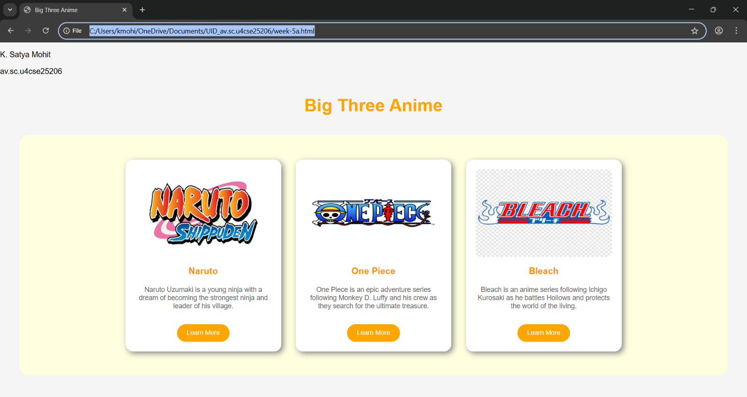

5B)Aim:Create a mini website using iframe with navigation (Home, About, Contact) that display content in the same page.
Program:-
<!DOCTYPE html>
<html>
<head>
<title>One Piece Website</title>
<style>
body {
margin: 0;
font-family: Arial, sans-serif;
background-color: whitesmoke;
}

header {
background-color: orangered;
color: white;
padding: 20px;
text-align: center;
font-size: 26px;
letter-spacing: 2px;
}

nav {
background-color: lightsalmon;
padding: 12px;
text-align: center;
}

nav a {
color: white;
text-decoration: none;
margin: 20px;
font-size: 18px;
font-weight: bold;
}

nav a:hover {
color: coral;
}

.frame-container {
text-align: center;
margin-top: 20px;
}

iframe {
width: 85%;
height: 400px;
border-radius: 12px;
border: 4px solid orangered;
background-color: white;
}
</style>
</head>
<body>
<p>K. Satya Mohit</p>
<p>av.sc.u4cse25206</p>
<header>One Piece</header>

<nav>
<a href="week-5b-manga.html" target="content">Manga</a>
<a href="week-5b-anime.html" target="content">Anime</a>
<a href="week-5b-liveaction.html" target="content">Live Action</a>
</nav>

<div class="frame-container">
<iframe name="content" src="week-5b-manga.html"></iframe>
</div>

</body>
</html>

Output:-
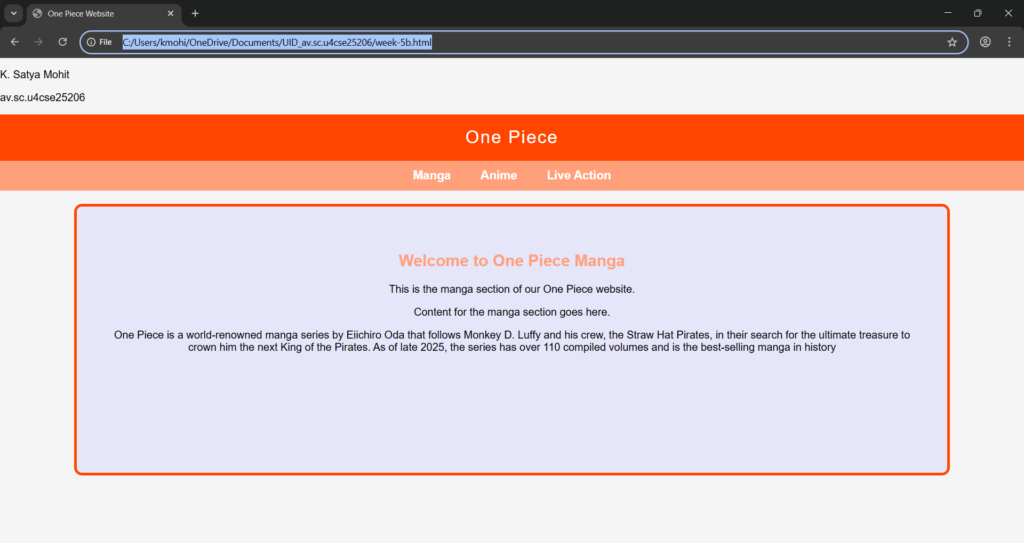
5.c)Aim: Design amrita login page by showcampus on home page.upon clicking on each campus
the details about each campus should be display on the same page use html and css to
design a stylish webpage
program:
Main file:

Week-6:
6.A) Aim: Design a responsive e-commerce application using the grid layout. This application should contain different categories of products such as electronics, clothing, home-appliances, books.
Program:
<!DOCTYPE html>

<html>
<head>
<title>My E-commerce Website</title>
<style>
body{
font-family: Arial, sans-serif;
margin: 0;
padding: 0;
background-color: black;
color: white;}
.container{
display: grid;
grid-template-rows: auto auto 1fr auto;
grid-template-columns: 200px 1fr;
grid-template-areas:
"header header"
"sale sale"
"sidebar main"
"footer footer";
gap: 10px;
padding: 10px;
}
.header{
grid-area: header;
background-color: navy;
padding: 10px;
text-align: center;
}
.sale{
grid-area: sale;
background-color: navy;
padding: 10px;
text-align: center;

}
.sidebar{
grid-area: sidebar;
background-color: navy;
padding: 10px;
}
.main{
grid-area: main;
background-color: navy;
padding: 10px;
display: grid;
grid-template-columns: repeat(2, 1fr);
gap: 10px;
}
.footer{
grid-area: footer;
background-color: navy;
padding: 10px;
text-align: center;
}
.product{
background-color:lightblue;
padding: 10px;
border-radius: 5px;
text-align: center;
}
.product-image{
width: 200px;
height: 200px;
}
.button{
background-color: white;
color: black;
border: 2px solid lightslategray;
padding: 10px 20px;
border-radius: 5px;
}
.button:hover{
background-color: lightslategray;
color: black;
border: 2px solid black;
}
</style>
</head>
<body>
<div class="container">
<div class="header">
<h1>MK Stores</h1>
</div>
<div class="sale">
<marquee behavior="scroll" direction="left" scrollamount="5">Big Sale! Up to 50% off on selected items. Don't miss out!</marquee>
</div>
<div class="sidebar">
<h2>Categories</h2>
<ul>
<li>Electronics</li>
<li>Clothing</li>
<li>home-appliances</li>
<li>books</li>
</ul>
</div>
<div class="main">
<div class="product">
<img class="product-image" src="https://m.media-amazon.com/images/S/pv-target-images/152e502c1f16c117f5bb5e34c6da2dcdc0bfe3caf48131cbedd3a3ed2f0060ea._SX1080_FMjpg_.jpg" alt="Electronic">
<h3>Electronics</h3>
<p>Price: $29.99</p>
<button class="button">Add to Cart</button>
</div>
<div class="product">
<img class="product-image" src="https://t4.ftcdn.net/jpg/04/77/91/07/360_F_477910771_V79eDAiLQxW4igi1jRTyt77F4Lz3CanP.jpg" alt="Clothing">
<h3>Clothing</h3>
<p>Price: $9.99</p>
<button class="button">Add to Cart</button>
</div>
<div class="product">
<img class="product-image" src="https://img.freepik.com/free-vector/household-appliances-realistic-composition_1284-65307.jpg?semt=ais_incoming&w=740&q=80" alt="Home Appliance">
<h3>Home Appliance</h3>
<p>Price: $19.99</p>
<button class="button">Add to Cart</button>
</div>
<div class="product">
<img class="product-image" src="https://img.freepik.com/free-vector/text-books-library-isolated-icon_24877-83372.jpg?semt=ais_incoming&w=740&q=80" alt="Book">
<h3>Book</h3>
<p>Price: $4.99</p>
<button class="button">Add to Cart</button>
</div>
</div>
<div class="footer">
<p>&copy; copyright MK Stores Website. All rights reserved.</p>
</div>
</div>
</body>
</html>
Output:-
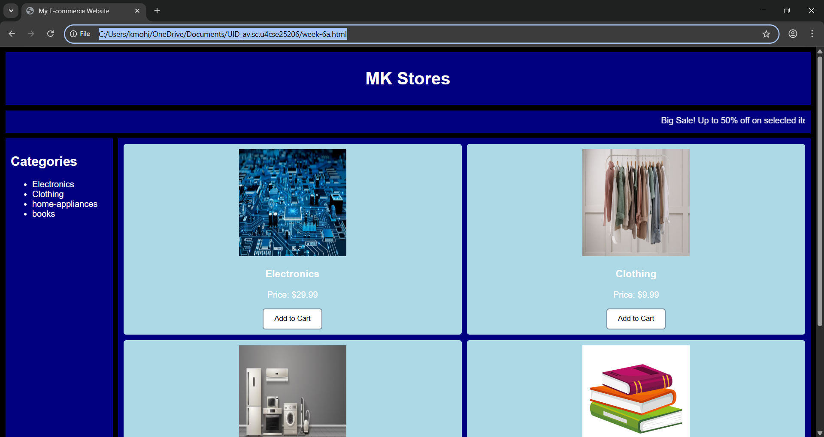
Explanation:
<DOCTYPE html> : the <!DOCTYPE html> element tells the web browser that this an HTML document
or this is the latest version of HTML
<html> : the <html> element is the root element of an HTML web page
<head> : the <head> element will contain meta data about the HTML web page
<title> : the <title> element specifies a title for the HTML Page
<body> : the <body> element contains all visible content all visible content like text , image , links ,
tables , etc
<h> : we used <h> element for heading
<p> : we used <p> element for the paragraph
<div>:we use <div> element for encapsulating the the divisions and easy to modify and
<button>: we use <button> element for button
<img>: we use <img> tag for displaying the image
We used layout in this program and its attributes like grid-template-rows, grid-template-coloums, grid-template-area to define the items space for the grid layout by dividing page into separate sections and use div tag make into small separate blocks
6.B) Aim: Design a responsive e-commerce application using the grid layout. This application should contain different categories of products such as electronics, clothing, home-appliances, books. Based on the category we select corresponding products should be displayed on the sidebar.
Program:
Main:
AV.SC.U4CSE25206-UID

<!DOCTYPE html>
<html>
<head>
<title>TOYS 4 TOYS</title>
<style>
body{
margin:0;
font-family:Arial;
color:#fff;
background:url("backgroundimages.jpg") center/cover fixed no-repeat;
}
body::before{
content:"";
position:fixed;
inset:0;
background:rgba(0,0,0,.75);
z-index:-1;
}
.container{
display:grid;
grid-template:
"header header" auto
"sale sale" auto
"sidebar main" 1fr
"footer footer" auto /220px 1fr;
gap:15px;
padding:15px;
}
.header,.sale,.sidebar,.main,.footer{
background:rgba(40,40,40,.65);
border-radius:12px;
padding:15px;
box-shadow:0 0 15px #000;
}
.header{grid-area:header;text-align:center;font-size:28px;letter-spacing:3px;}
.sale{grid-area:sale;overflow:hidden;white-space:nowrap;height:40px;position:relative;}
.sale p{
position:absolute;
color:#00ffd5;
font-size:20px;
animation:move 10s linear infinite;
}
@keyframes move{
from{left:-100%;}
to{left:100%;}
}
.sidebar{grid-area:sidebar}
.sidebar ul{list-style:none;padding:0}
.sidebar li{margin:15px 0}
.sidebar a{
color:#fff;
text-decoration:none;
font-size:18px;
transition:.3s;
}
.sidebar a:hover{color:#00ffd5;padding-left:8px}
.main{grid-area:main}
iframe{width:100%;height:520px;border:0;background:rgba(0,0,0,.5);border-radius:10px}
.footer{grid-area:footer;text-align:center;font-size:14px;opacity:.85}
</style>
</head>
<body>
<div class="container">
<div class="header">MK Stores</div>
<div class="sale">
<p>🔥 SPECIAL SALE - UP TO 50% OFF ON ALL ITEMS 🔥</p>
</div>
<div class="sidebar">
<h2>Categories</h2>
<ul>
<li><a href="electronics.html" target="contentFrame">Electronics</a></li>
<li><a href="clothing.html" target="contentFrame">Clothing</a></li>
<li><a href="home-appliances.html" target="contentFrame">Home Appliances</a></li>
<li><a href="books.html" target="contentFrame">Books</a></li>
</ul>
</div>
<div class="main">
<iframe name="contentFrame"></iframe>
</div>
<div class="footer">
© MK Stores Website
</div>
</div>
</body>
</html>
Electronics-
<!DOCTYPE html>
<html>
<head>
<title>Electronics</title>
<style>
body{
font-family: Arial, sans-serif;
margin:0;
padding:20px;
background-color: gray;
}

.container{
display:grid;
grid-template-columns: 1fr 1fr;
grid-template-rows: auto auto;
gap:20px;
}

.card{
background:white;
padding:20px;
border-radius:10px;
box-shadow:0 4px 10px rgba(0,0,0,0.2);
text-align:center;
}

.card-img{
width:200px;
height:200px;
border-radius:10px;
margin-bottom:10px;
}

.price{
font-size:18px;
color:green;
margin-top:10px;
}
</style>
</head>
<body>
<div class="container">
<div class="card">
<img class="card-img" src="https://encrypted-tbn0.gstatic.com/images?q=tbn:ANd9GcSC7VnniwcNQsLdjls0SqunWSIowAqBtijKxg&s" alt="smartphone">
<h2>Smartphone</h2>
<p>Latest model with advanced features.</p>
<p class="price">$29.99</p>
</div>
<div class="card">
<img class="card-img" src="https://img.freepik.com/free-photo/laptop-with-sun-background_1232-429.jpg?semt=ais_hybrid&w=740&q=80" alt="Laptop">
<h2>Laptop</h2>
<p>Portable computer for work and entertainment.</p>
<p class="price">$34.99</p>
</div>
<div class="card">
<img class="card-img" src="https://encrypted-tbn0.gstatic.com/images?q=tbn:ANd9GcSpgm2OTEUQ2nOMtfU3TgYTD1Xg_xFeBfYgXw&s" alt="Smart Watch">
<h2>Smart Watch</h2>
<p>Wearable technology for fitness and communication.</p>
<p class="price">$19.99</p>
</div>
<div class="card">
<img class="card-img" src="https://store.storeimages.cdn-apple.com/1/as-images.apple.com/is/airpods-4-anc-select-202409_FMT_WHH?wid=752&hei=636&fmt=jpeg&qlt=90&.v=1725502639798" alt="Airpods">
<h2>Airpods</h2>
<p>Wireless earbuds with noise cancellation.</p>
<p class="price">$14.99</p>
</div>
</div>
</body>
</html>
Clothing:
<!DOCTYPE html>
<html>
<head>
<title>Clothing</title>
<style>
body{
font-family: Arial, sans-serif;
margin:0;
padding:20px;
background-color: gray;
}

.container{
display:grid;
grid-template-columns: 1fr 1fr;
grid-template-rows: auto auto;
gap:20px;
}

.card{
background:white;
padding:20px;
border-radius:10px;
box-shadow:0 4px 10px rgba(0,0,0,0.2);
text-align:center;
}

.card-img{
width:200px;
height:200px;
border-radius:10px;
margin-bottom:10px;
}

.price{
font-size:18px;
color:green;
margin-top:10px;
}
</style>
</head>
<body>
<div class="container">
<div class="card">
<img class="card-img" src="https://i.pinimg.com/originals/b2/09/c0/b209c05e517088a17d16f5401b6a616f.jpg" alt="Shirt">
<h2>Shirts</h2>
<p>Comfortable and stylish shirts for everyday wear.</p>
<p class="price">$9.99</p>
</div>
<div class="card">
<img class="card-img" src="https://frenchcrown.in/cdn/shop/files/J475_2.jpg?v=1754139428&width=3500" alt="Jeans">
<h2>Jeans</h2>
<p>Comfortable and stylish jeans </p>
<p class="price">$14.99</p>
</div>
<div class="card">
<img class="card-img" src="https://thumbs.dreamstime.com/b/mens-shorts-isolated-white-71451873.jpg" alt="Shorts">
<h2>Shorts</h2>
<p>Comfortable and stylish shorts for everyday wear.</p>
<p class="price">$7.99</p>
</div>
<div class="card">
<img class="card-img" src="https://encrypted-tbn0.gstatic.com/images?q=tbn:ANd9GcSj9dEFMDZG32etPpUbUgtYzTEQGByJQbbPug&s" alt="T-Shirts">
<h2>T-Shirts</h2>
<p>Comfortable and stylish t-shirts for everyday wear.</p>
<p class="price">$9.99</p>
</div>
</div>
</body>
</html>

Home-appliances:
<!DOCTYPE html>
<html>
<head>
<title>Home Appliances</title>
<style>
body{
font-family: Arial, sans-serif;
margin:0;
padding:20px;
background-color: gray;
}

.container{
display:grid;
grid-template-columns: 1fr 1fr;
grid-template-rows: auto auto;
gap:20px;
}

.card{
background:white;
padding:20px;
border-radius:10px;
box-shadow:0 4px 10px rgba(0,0,0,0.2);
text-align:center;
}

.card-img{
width:200px;
height:200px;
border-radius:10px;
margin-bottom:10px;
}

.price{
font-size:18px;
color:green;
margin-top:10px;
}
</style>
</head>
<body>
<div class="container">
<div class="card">
<img class="card-img" src="https://www.lg.com/content/dam/channel/wcms/in/images/split-ac/gallery/updated-1-2-gallery/US-Q19BNZE-2010x1334-1.jpg/jcr:content/renditions/thum-1600x1062.jpeg" alt="Air Conditioner">
<h2>Air Conditioner</h2>
<p>Efficient and reliable air conditioning for your home.</p>
<p class="price">$29.99</p>
</div>
<div class="card">
<img class="card-img" src="https://electronicparadise.in/cdn/shop/files/LG_REF_GR-H812HLHM_9.jpg?v=1728896327&width=1406" alt="Refrigerator">
<h2>Refrigerator</h2>
<p>Large capacity refrigerator for your household needs.</p>
<p class="price">$149.99</p>
</div>
<div class="card">
<img class="card-img" src="https://encrypted-tbn0.gstatic.com/images?q=tbn:ANd9GcTatw7NgSRxxvBWXd5Yl_p4L3cPA180nzqY2g&s" alt="Washing Machine">
<h2>Washing Machine</h2>
<p>Efficient and reliable washing machine for your home.</p>
<p class="price">$89.99</p>
</div>
<div class="card">
<img class="card-img" src="https://cms-assets.bajajfinserv.in/is/image/bajajfinance/mini-microwave-oven?scl=1&fmt=png-alpha" alt="Microwave Oven">
<h2>Microwave Oven</h2>
<p>Convenient and efficient microwave oven for quick heating.</p>
<p class="price">$39.99</p>
</div>
</div>
</body>
</html>
Books:
<!DOCTYPE html>
<html>
<head>
<title>Books</title>
<style>
body{
font-family: Arial, sans-serif;
margin:0;
padding:20px;
background-color: gray;
}

.container{
display:grid;
grid-template-columns: 1fr 1fr;
grid-template-rows: auto auto;
gap:20px;
}

.card{
background:white;
padding:20px;
border-radius:10px;
box-shadow:0 4px 10px rgba(0,0,0,0.2);
text-align:center;
}

.card-img{
width:200px;
height:200px;
border-radius:10px;
margin-bottom:10px;
}

.price{
font-size:18px;
color:green;
margin-top:10px;
}
</style>
</head>
<body>
<div class="container">
<div class="card">
<img class="card-img" src="https://encrypted-tbn0.gstatic.com/images?q=tbn:ANd9GcQwDNch5NQDwYrAOarN6xMCI2XZYrcsn8Xf9w&s" alt="The Great Gatsby">
<h2>The Great Gatsby</h2>
<p>A classic American novel about the Jazz Age.</p>
<p class="price">$12.99</p>
</div>
<div class="card">
<img class="card-img" src="https://www.crossword.in/cdn/shop/products/crosswordonline-books-default-title-harry-potter-and-the-philosopher-s-stone-j-k-rowling-40421717704921.jpg?v=1745732396" alt="Harry Potter and the Sorcerer's Stone">
<h2>Harry Potter and the Sorcerer's Stone</h2>
<p>Harry Potter, an eleven-year-old orphan, discovers that he is a wizard and is invited to study at Hogwarts. Even as he escapes a dreary life and enters a world of magic, he finds trouble awaiting him.</p>
<p class="price">$14.99</p>
</div>
<div class="card">
<img class="card-img" src="https://encrypted-tbn0.gstatic.com/images?q=tbn:ANd9GcRfr2HICPQZGjV2TqnGldIvQcO7ToJqORPJnA&s" alt="A Wimpy Kid Book">
<h2>Wimpy Kid Book</h2>
<p>A humorous children's book about a relatable character.</p>
<p class="price">$11.99</p>
</div>
<div class="card">
<img class="card-img" src="https://encrypted-tbn0.gstatic.com/images?q=tbn:ANd9GcReVo4KYmcwAMzNQy2_Larrs0NfPGXuHEwkVQ&s" alt="To Kill a Mockingbird">
<h2>To Kill a Mockingbird</h2>
<p>A gripping tale of racial injustice and childhood innocence.</p>
<p class="price">$13.99</p>
</div>
</div>
</body>
</html>
OUTPUT:
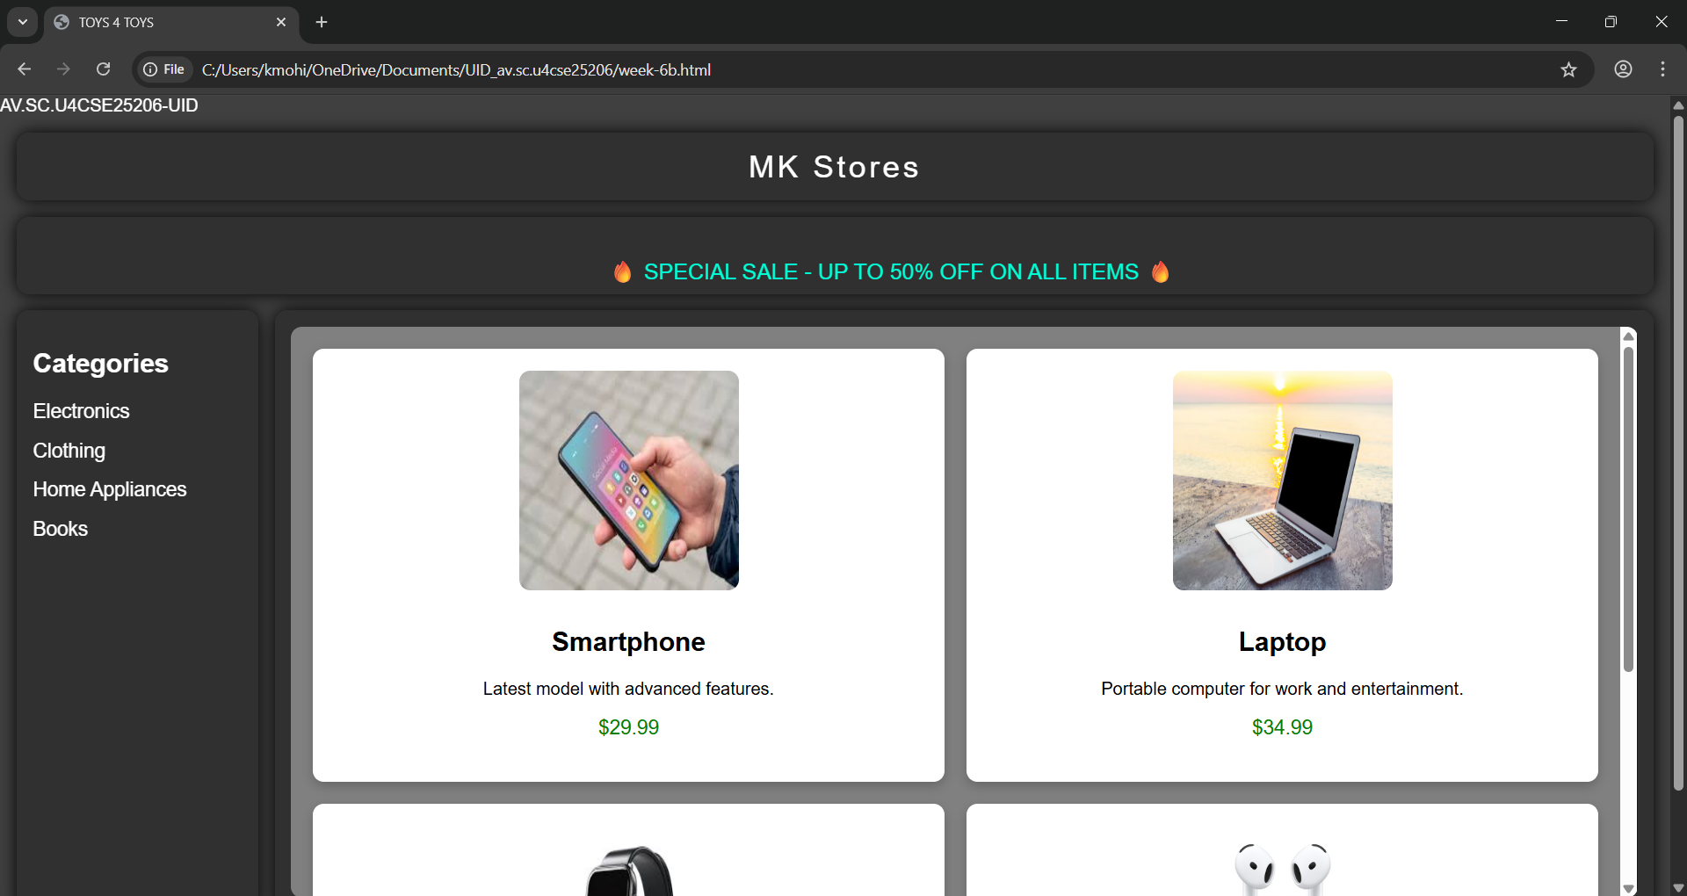
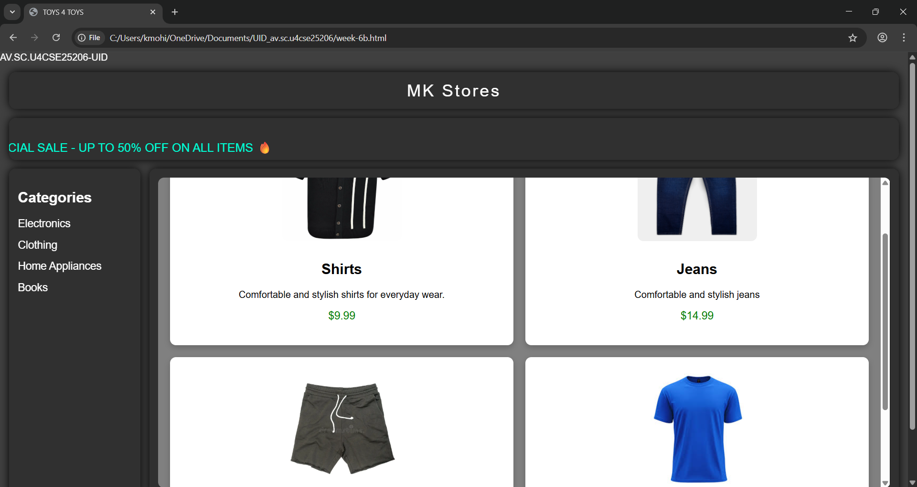
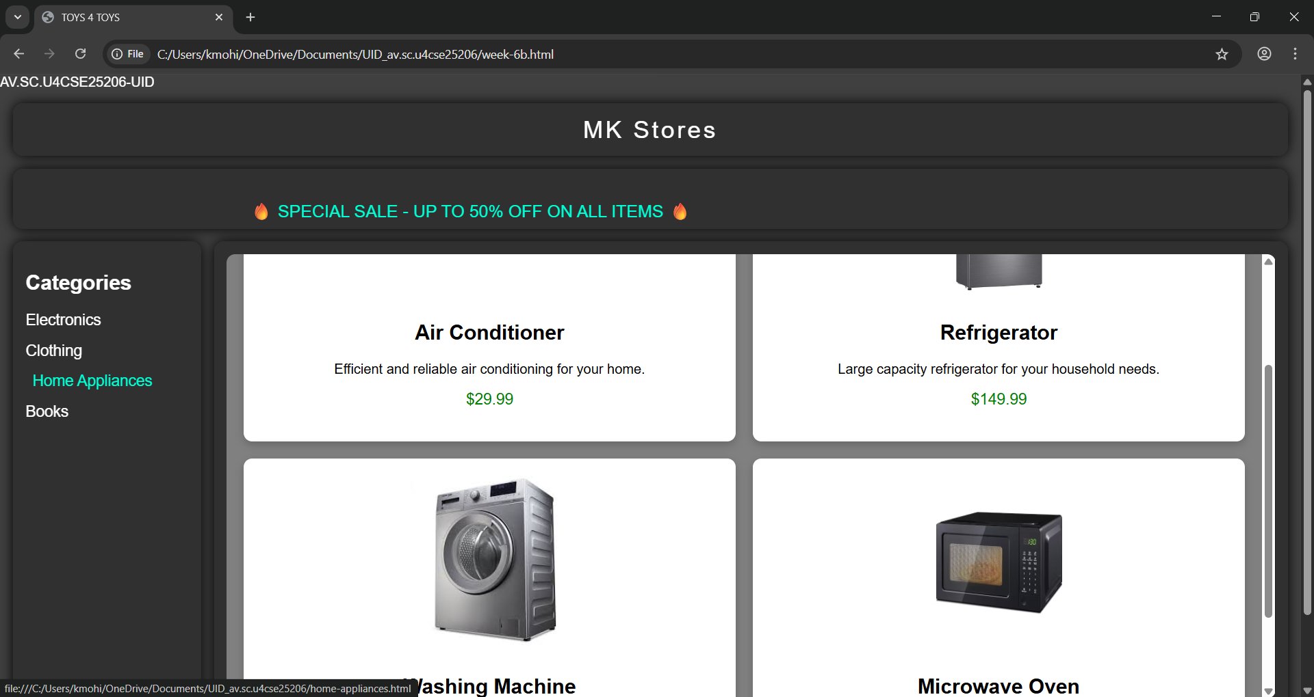
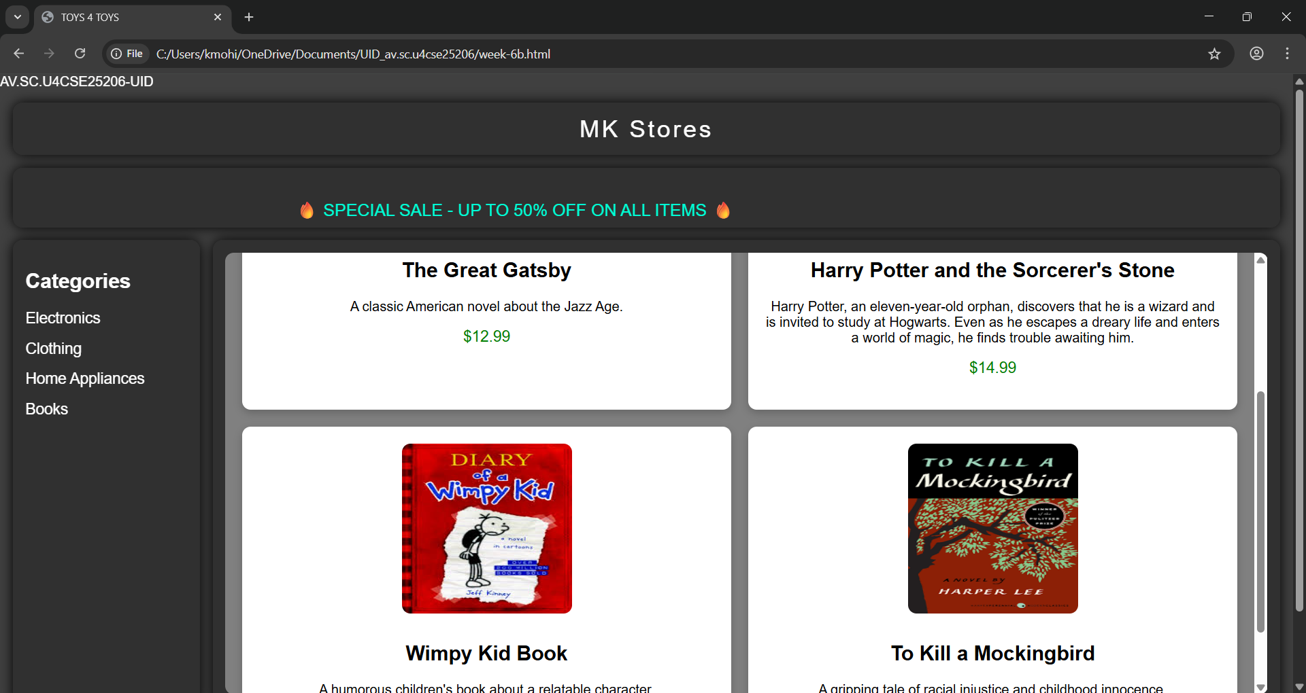
Explanation:
<DOCTYPE html> : the <!DOCTYPE html> element tells the web browser that this an HTML document
or this is the latest version of HTML
<html> : the <html> element is the root element of an HTML web page
<head> : the <head> element will contain meta data about the HTML web page
<title> : the <title> element specifies a title for the HTML Page
<body> : the <body> element contains all visible content all visible content like text , image , links ,
tables , etc
<h> : we used <h> element for heading
<p> : we used <p> element for the paragraph
<div>:we use <div> element for encapsulating the the divisions and easy to modify and
<button>: we use <button> element for button
<img>: we use <img> tag for displaying the image
<I frame>:we <iframe> tag to create link other webpages into it.
We used layout in this program and its attributes like grid-template-rows, grid-template-coloums, grid-template-area to define the items space for the grid layout by dividing page into separate sections and use div tag make into small separate blocks and we used I frames to link the sub webpages into main webpage we attribute target and name for easy understanding and reduce the code .

Week -7:
7.A) Aim: create a GitHub account and create a repository in it and push all the week 6 code files in it.
Procedure :
Step 1: browse for GitHub and enter it.
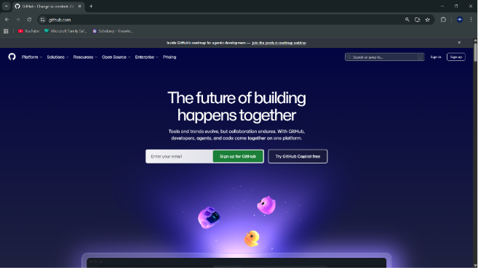
Step 2:login to GitHub account.
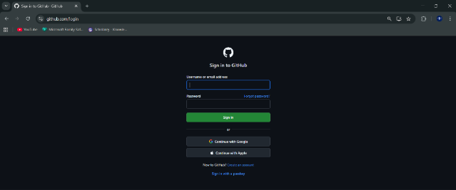
Step 3:create a repository after login by clicking new.
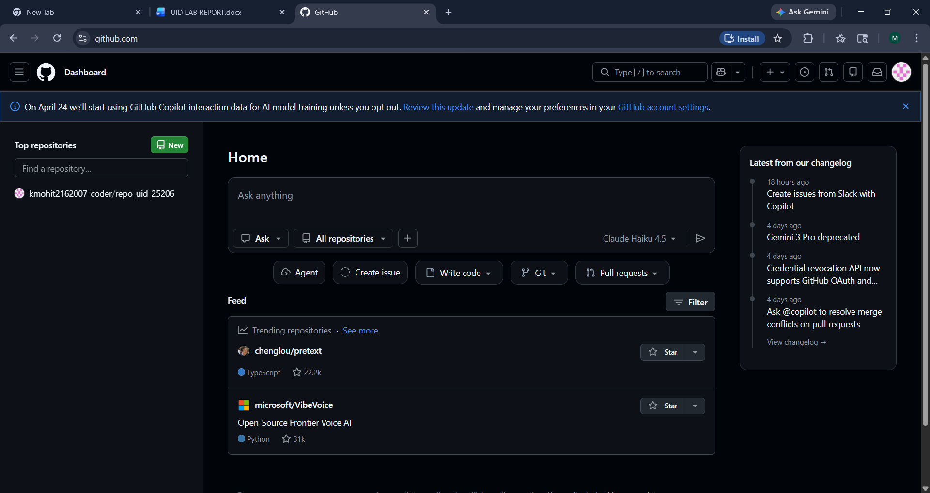
Step 4:specify the repository specifications.
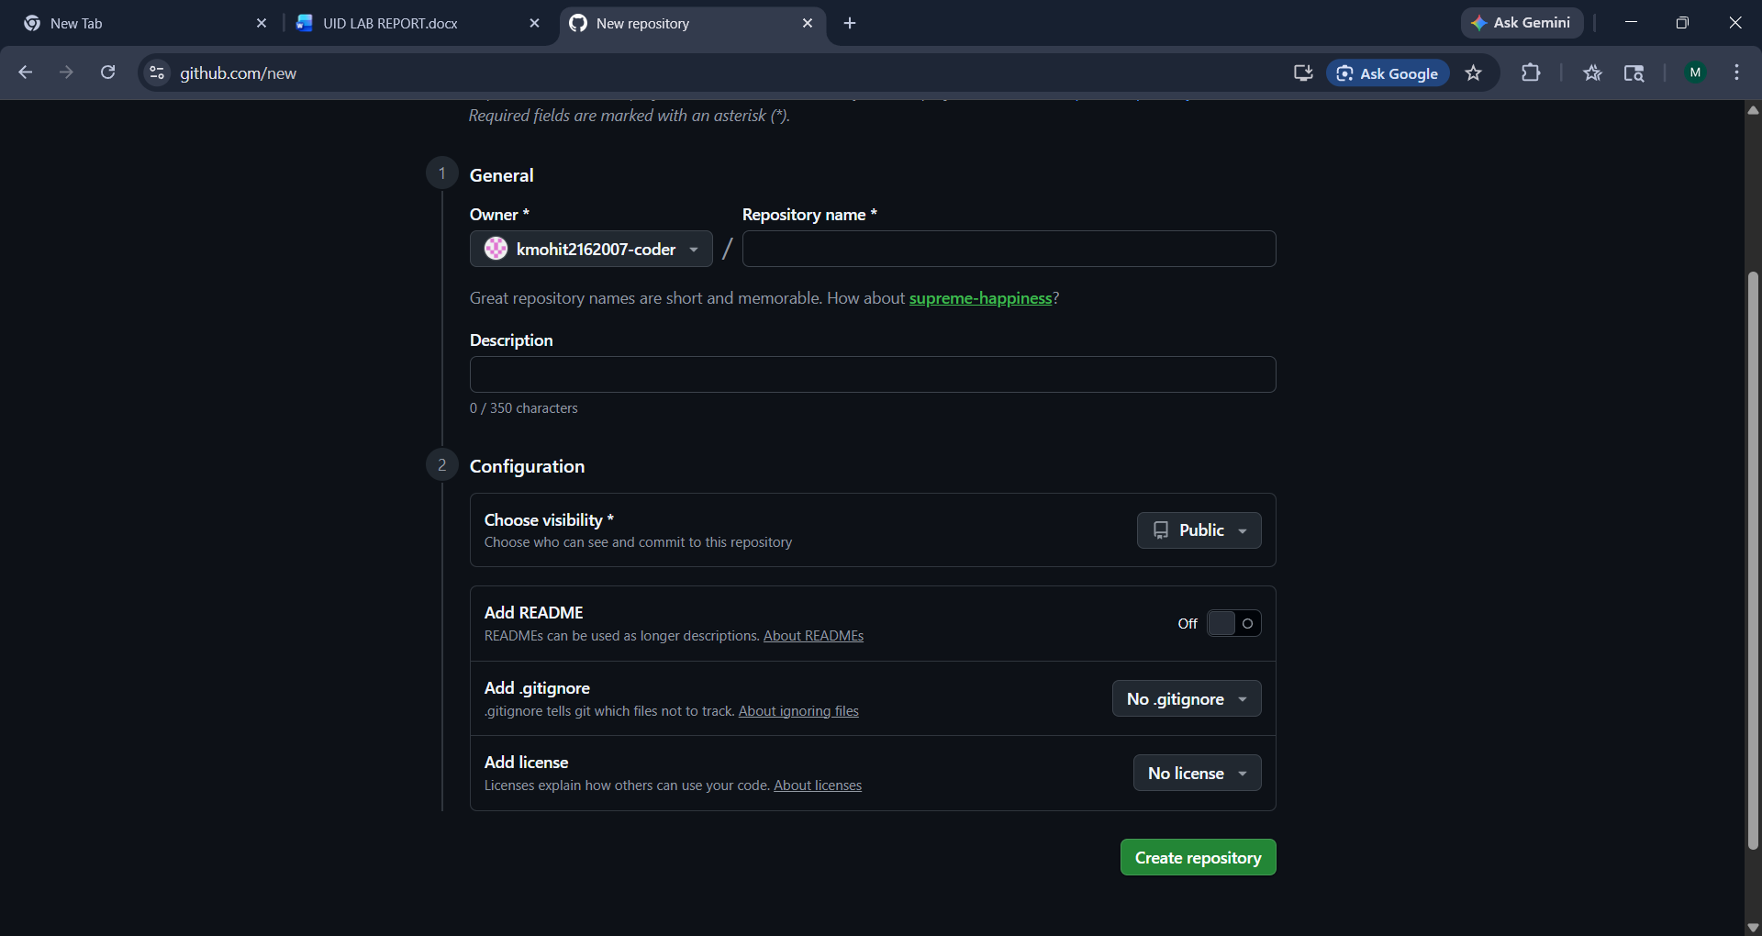
Step 5:download GitHub desktop and Lauch it .
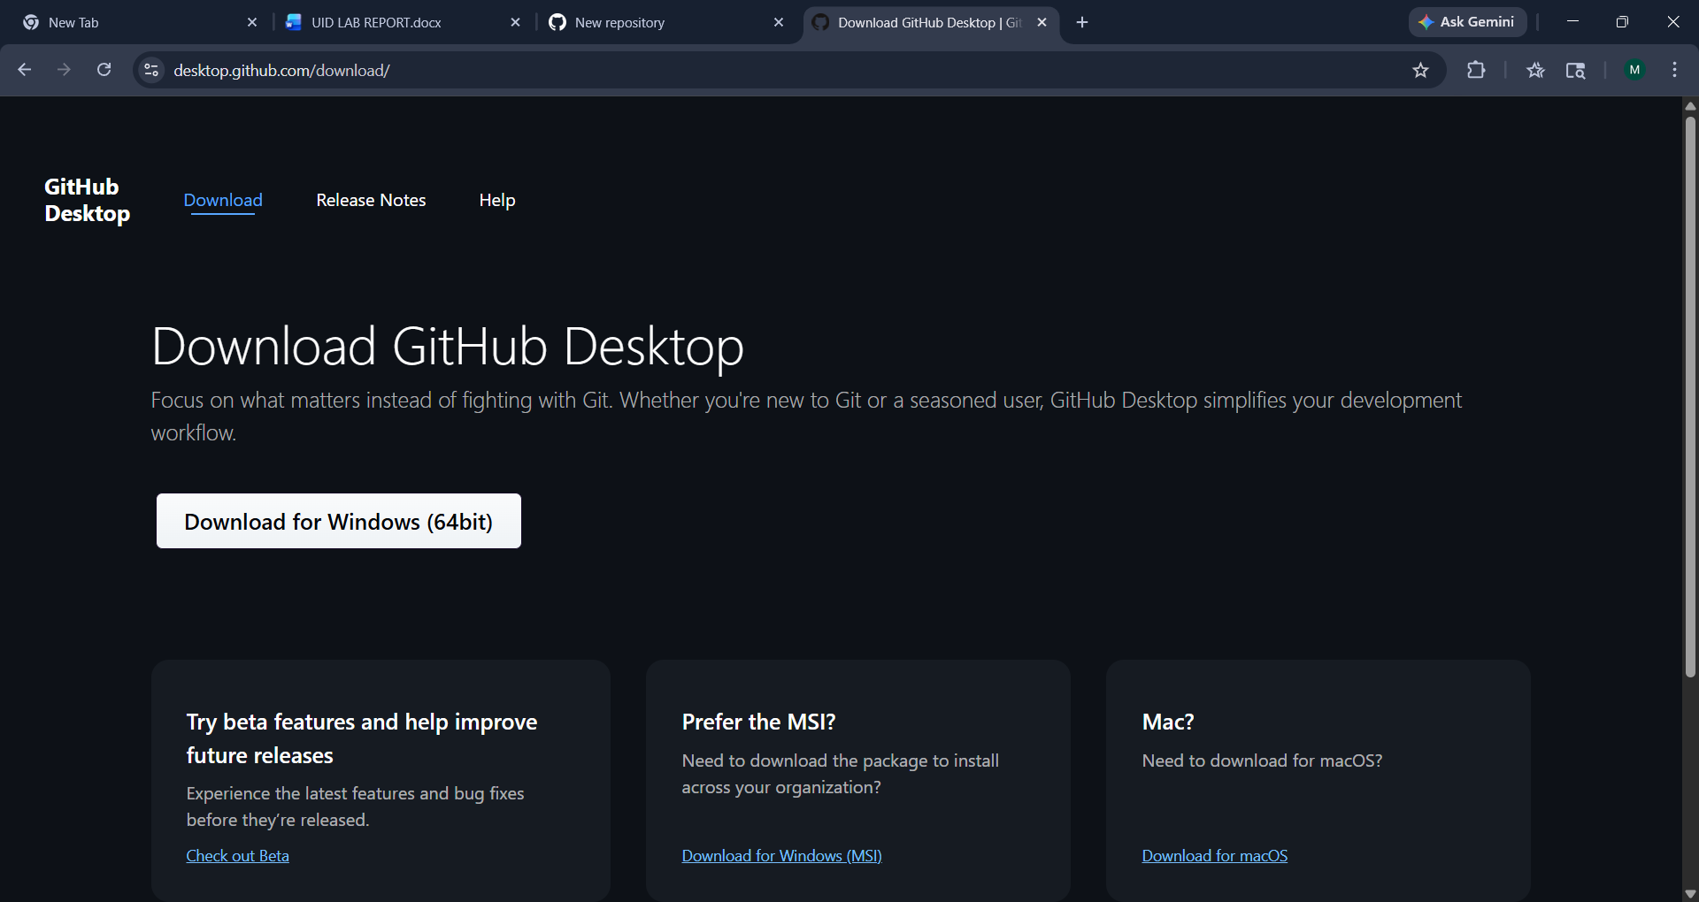
Step 6:add the repository to it .
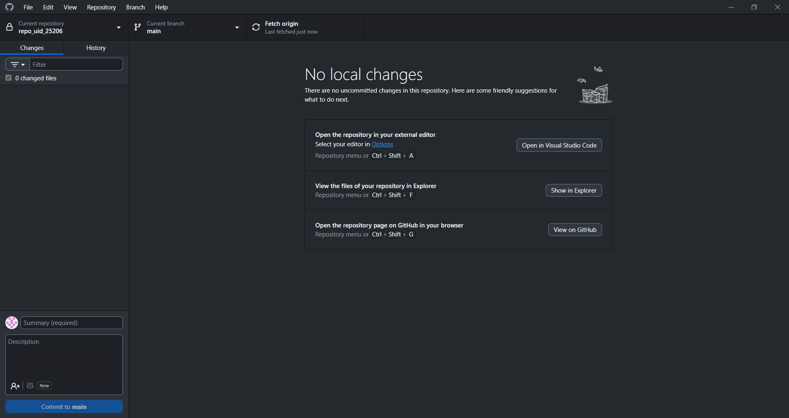
Step 7:add the vs code file to the GitHub desktop.
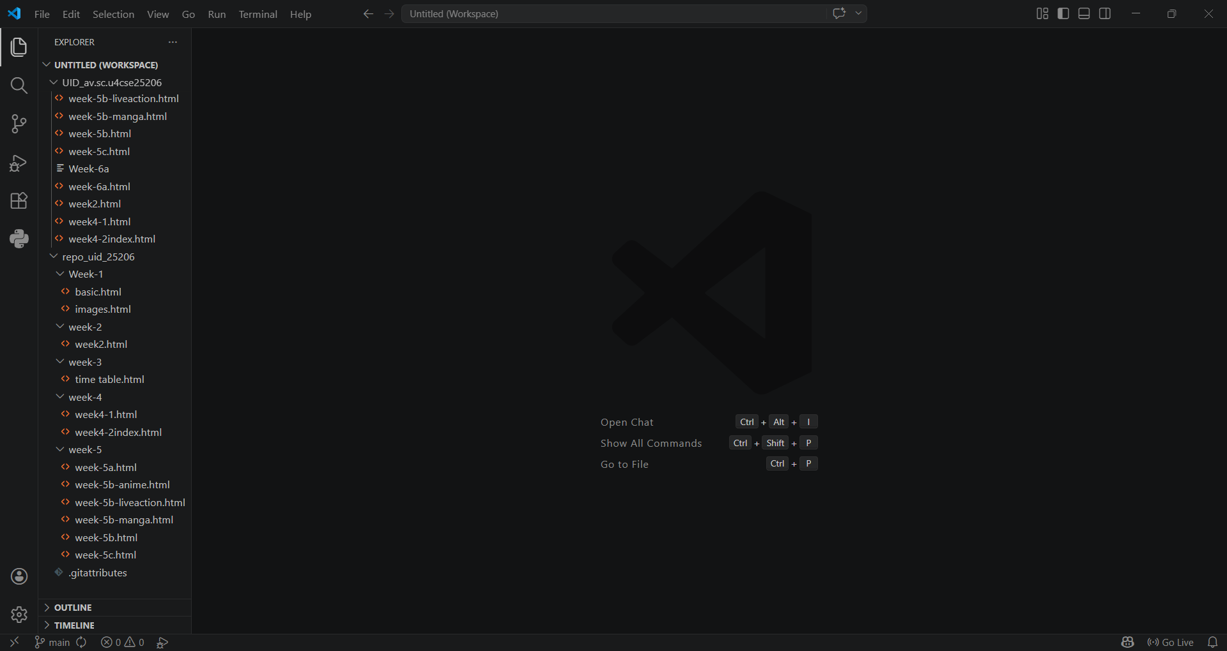
Step 8:add commit to it and the files to repository and sync the changes . it automatically
pushes the files .
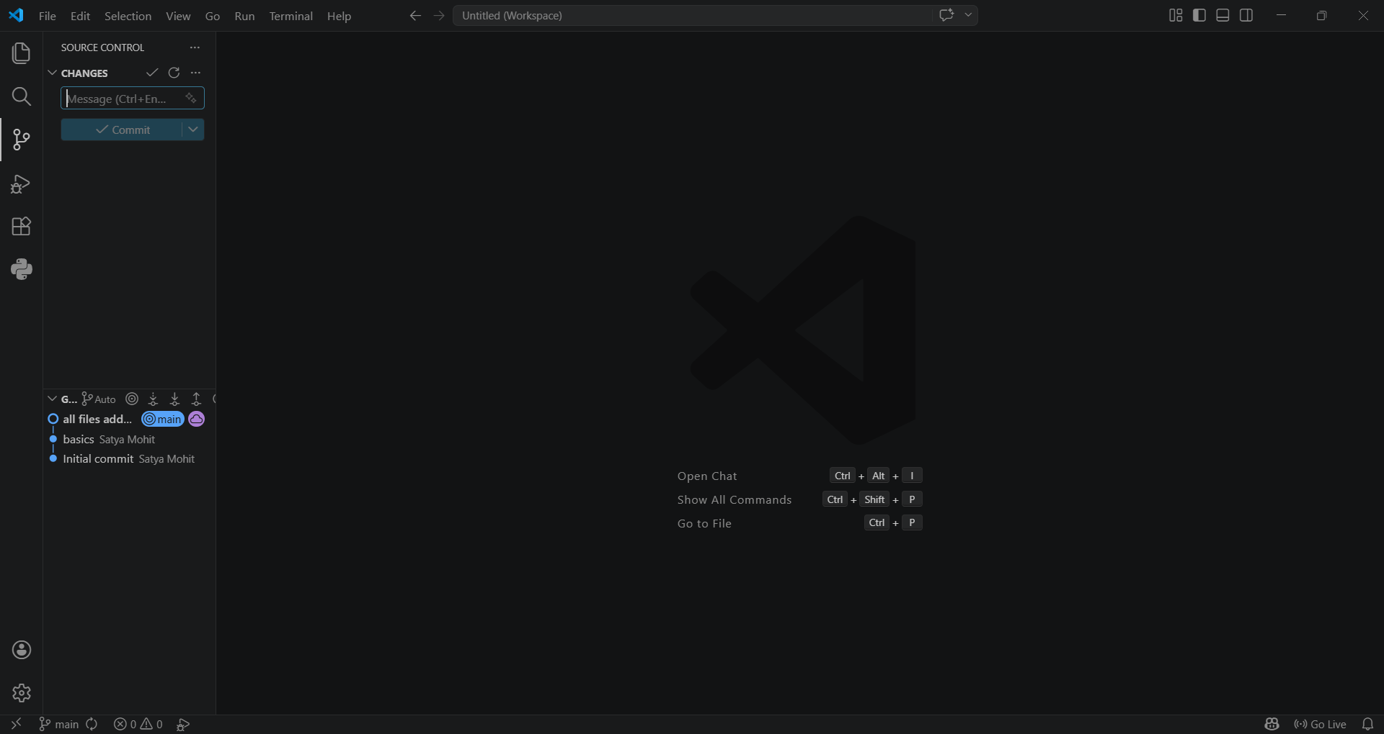
Step 9:now go to browser and check it . it will show all the new added files in the repository .
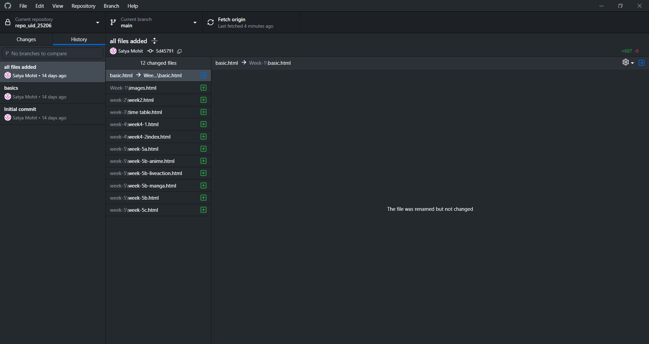
My repository link for the uid all week’s work:
https://github.com/kmohit2162007-coder/repo_uid_25206
Week-8:
8.A) Aim: create a web page that displays a square that continuously rotates 360 using css animation
Program:
AV.SC.U4CSE25206-UID
<!DOCTYPE html>
<html>
<head>
<title>Rotating Square 360</title>
<style>
body {
margin: 0;
height: 100vh;
display: flex;
flex-direction: column;
justify-content: flex-start;
align-items: center;
background-color: #000;
font-family: Arial, sans-serif;
padding-top: 50px;
}
.square {
width: 120px;
height: 120px;
background: linear-gradient(45deg, #ff6ec4, #7873f5);
border-radius: 12px;
box-shadow: 0 0 20px #ff6ec4, 0 0 40px #7873f5;
animation: rotate 3s linear infinite;
}
@keyframes rotate {
from {
transform: rotate(0deg);
}
to {
transform: rotate(360deg);
}
}
</style>

</head>

<body>
<h1 style="color: #fff;">Rotating Square</h1>
<div class="square"></div>
</body>

</html>
Output:
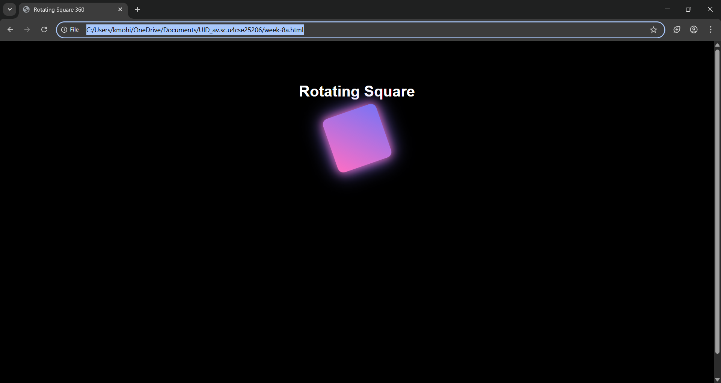

Explanation:
<DOCTYPE html> : the <!DOCTYPE html> element tells the web browser that this an HTML document
or this is the latest version of HTML
<html> : the <html> element is the root element of an HTML web page
<head> : the <head> element will contain meta data about the HTML web page
<title> : the <title> element specifies a title for the HTML Page
<body> : the <body> element contains all visible content all visible content like text , image , links ,
tables , etc
<h> : we used <h> element for heading
<div>:we use <div> element for encapsulating the the divisions and easy to modify and
@keyframes:we use @keyframes for animation from starting to end transformation.
We used animation shorthand property for these things to mention the animations preferences and use keyframes for mentioning the positions of the animation and used style attribute and some value properties for look and we used internal css in it .

8.B)Aim :create a ball that moves up and down continuously using css animation
AV.SC.U4CSE25206-UID
<!DOCTYPE html>
<html>
<head>
<title>Bouncing Ball</title>
<style>
body {
margin: 0;
height: 100vh;
display: flex;
flex-direction: column;
align-items: center;
justify-content: flex-start;
background: #000;
font-family: Arial, sans-serif;
}
h1 {
margin-top: 20px;
color: #fff;
}
.ball {
width: 80px;
height: 80px;
background: linear-gradient(45deg, #ff6ec4, #7873f5);
border-radius: 50%;
margin-top: 50px;
animation: bounce 1.5s ease-in-out infinite;
}
@keyframes bounce {
0% {
transform: translateY(0);
}
50% {
transform: translateY(100px);
}
100% {
transform: translateY(0);
}
}
</style>
</head>
<body>
<h1>Bouncing Ball</h1>
<div class="ball"></div>
</body>
</html>
Output:
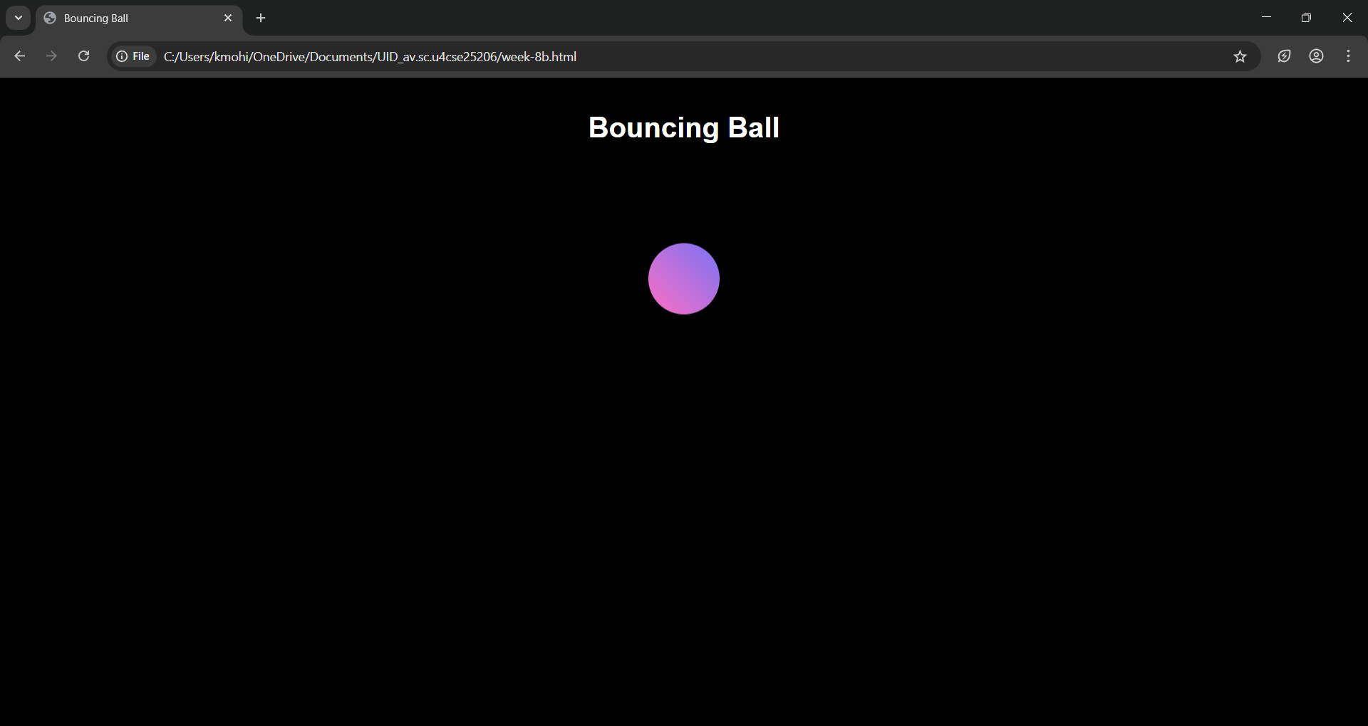
Explanation:
<DOCTYPE html> : the <!DOCTYPE html> element tells the web browser that this an HTML document
or this is the latest version of HTML
<html> : the <html> element is the root element of an HTML web page
<head> : the <head> element will contain meta data about the HTML web page
<title> : the <title> element specifies a title for the HTML Page
<body> : the <body> element contains all visible content all visible content like text , image , links ,
tables , etc
<h> : we used <h> element for heading
<div>:we use <div> element for encapsulating the the divisions and easy to modify and
@keyframes:we use @keyframes for animation from starting to end transformation.
We used animation shorthand property for these things to mention the animations preferences and use keyframes for mentioning the positions of the animation and used style attribute and some value properties for look and we used internal css in it .
8.C)Aim :create a circle that moves horizontally and rotates At the same time
Program:
AV.SC.U4CSE25206-UID
<!DOCTYPE html>
<html>
<head>
<title>Moving Rotating Circle</title>
<style>
body {
margin: 0;
height: 100vh;
display: flex;
flex-direction: column;
align-items: center;
justify-content: flex-start;
background: #000;
overflow: hidden;
font-family: Arial, sans-serif;
}
h1 {
margin-top: 20px;
color: #ffffff;
}
.circle {
width: 80px;
height: 80px;
background: linear-gradient(45deg, #ff6ec4, #7873f5);
border-radius: 50%;
margin-top: 50px;
animation: moveRotate 3s linear infinite;
}
@keyframes moveRotate {
0% {
transform: translateX(-150px) rotate(0deg);
}
50% {
transform: translateX(150px) rotate(180deg);
}
100% {
transform: translateX(-150px) rotate(360deg);
}
}
</style>
</head>
<body>
<h1>Moving Rotating Circle</h1>
<div class="circle"></div>
</body>
</html>

Output:
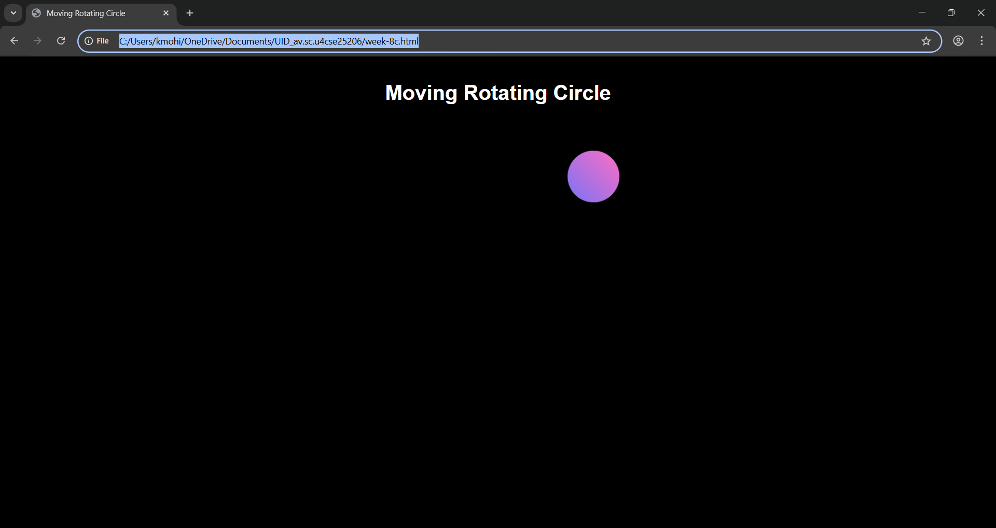
Explanation:
<DOCTYPE html> : the <!DOCTYPE html> element tells the web browser that this an HTML document
or this is the latest version of HTML
<html> : the <html> element is the root element of an HTML web page
<head> : the <head> element will contain meta data about the HTML web page
<title> : the <title> element specifies a title for the HTML Page
<body> : the <body> element contains all visible content all visible content like text , image , links ,
tables , etc
<h> : we used <h> element for heading
<div>:we use <div> element for encapsulating the the divisions and easy to modify and
@keyframes:we use @keyframes for animation from starting to end transformation.
We used animation shorthand property for these things to mention the animations preferences and use keyframes for mentioning the positions of the animation and used style attribute and some value properties for look and we used internal css in it .

